Web-Based Evaluations

User Manual

By: Tanuj Rane, Logan Racer, Dalton Stenzel, & Anthony Cinicola

11/22/2022

Contents

Section 1 Login 3

1.1 Logging In 3

1.2 First Time Login In 3

1.3 Password Recovery 4

1.4 Home, Account, & Logout Navigation Bar Options 6

Section 2 Admin Abilities 6

2.1 Adding Users 6

2.2 Viewing the Users 12

2.3 Editing Existing Users 13

2.4 Deleting Existing Users 15

Section 3 Evaluator Admin Abilities 18

3.1 Evaluations Form Navigation Bar Options 18

3.1.1 Uploading a New Evaluation 18

3.1.2 Downloading an Evaluation Analysis 22

3.1.3 Deleting Evaluation Forms 23

3.2 Groups Navigation Bar Options 24

3.2.1 Groups Button: Adding Groups 24

3.2.2 Viewing Groups and Previewing Evaluations 26

3.2.3 Groups Button: Editing a Group 28

3.2.4 Groups Button: Deleting/Archiving a Group 31

3.2.5 Groups Button: Chart Generation/Download Analysis for a Group 32

3.3 Archive Navigation Bar Options 34

Section 4 Users Abilities 35

4.1 Evaluation 35

Section 5 Evaluator Abilities 38

5.1 Evaluate 38

# Section 1 Login

## 1.1 Logging In

This program is designed to allow different types of users to be able to access evaluations in some form depending on certain rules and situations. Upon completing setup, after reading the installation manual, and running the program class “WebBasedEvaluationsApplications.java”, the user can either “Login” or “Reset Password” at the “localhost:8080/login” URL. In order to login, a user must provide an appropriate email address and password into the respective boxes on the webpage.

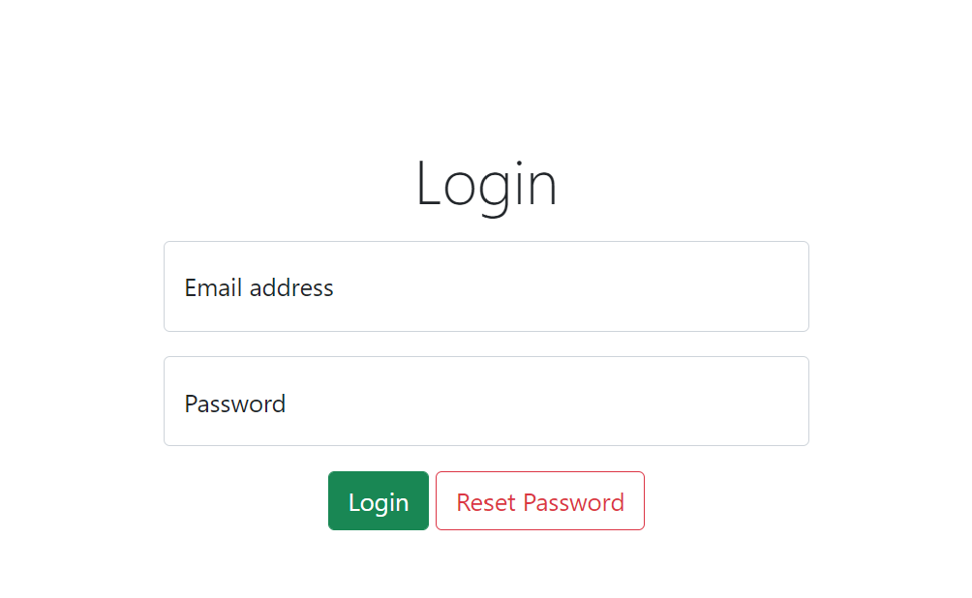

**Default view**

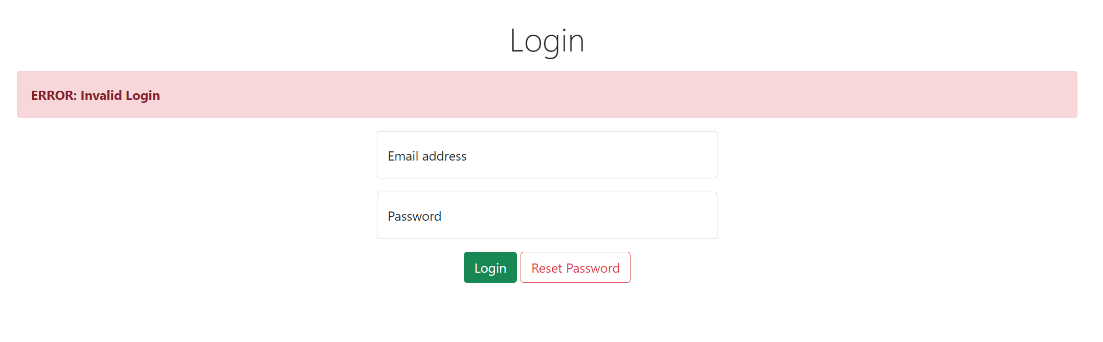

**View upon entering incorrect credentials**

## 1.2 First Time Login In

New users will be prompted with a window in order to reset their password upon logging in. The user must provide a password of their own, where is must be retyped in the “Reenter Password” box as well, and click “Update User &Return to Login”. If the update was successful, then the user will be taken back to the login screen

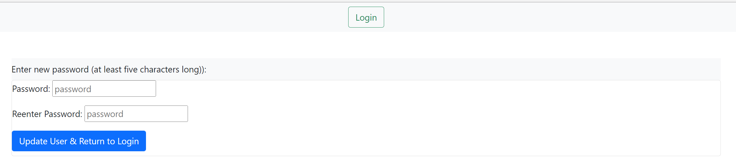

**Default view**

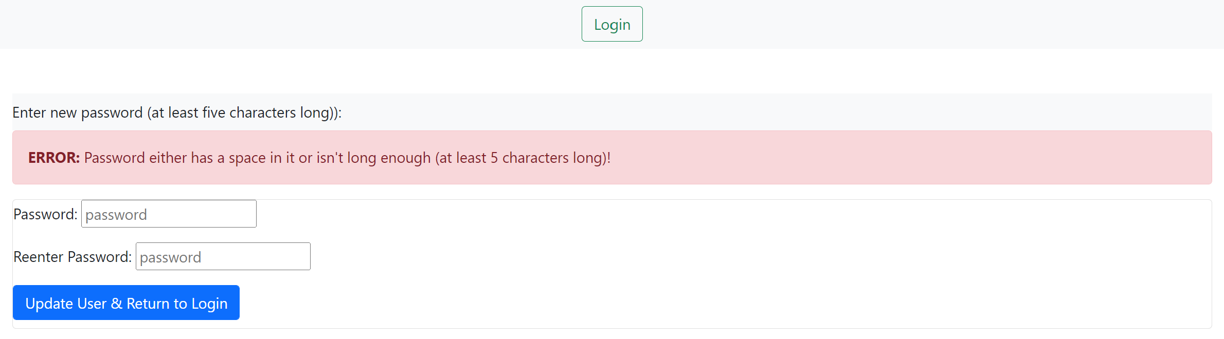

**View upon providing an inappropriate password and clicking “Update User”**

## 1.3 Password Recovery

Clicking on “Reset Password” instead of attempting to login will display a page where the user can enter in an email in order to try and receive a link for resetting their password. Upon entering an email address that is a part of the database of users, an email will be sent by an address called [spring.web.eval@gmail.com](mailto:spring.web.eval@gmail.com). The email will have “Password Reset” for the subject of the mail, while a link will be provided in the body to reset the user’s password. Entering in an email address that does not have an account associated with it will notify the user that an email failed to be sent.

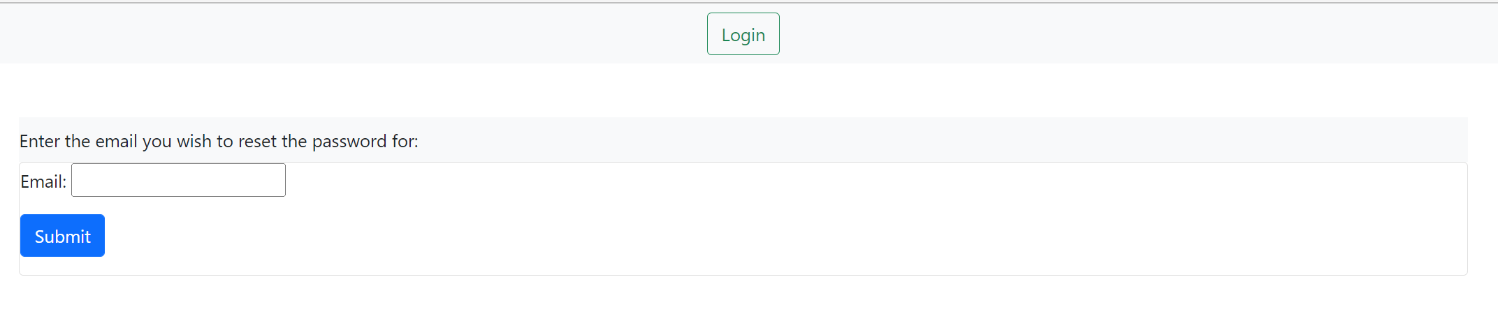

**Default view**

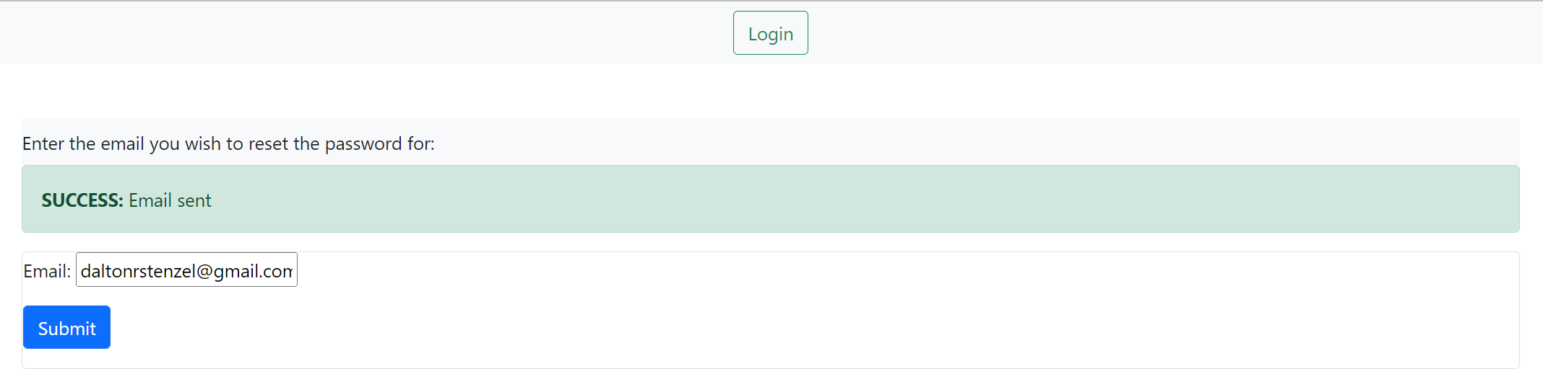

**View upon entering an email address present in the database**

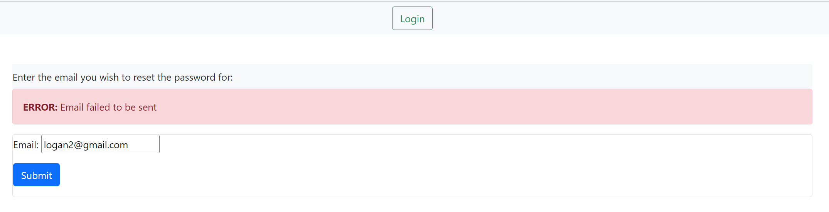

**View after entering an email that does not exist in the database**

Once an email gets sent, it is very likely for it to end up in the “Spam” box of the user’s email service. Be sure to check the spam folder. Upon receiving and email with the title “Password Reset”, open it to reveal the body message mentioning the 10-minute time limit in order to use the link as well as the link itself.

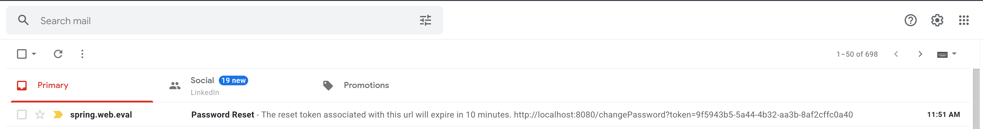

After clicking on the link provided in the email, the user will be taken to a webpage where two text boxes are provided. The webpage is the same as the “First Time Log In” section’s page. The text boxes must be exactly the same in order to have the password saved. The newly inputted password will be automatically encrypted and saved to the database upon clicking the submit button. A successful password change will redirect the user to the login screen.



**Default view**



**View upon failing to have the two text boxes’ content match**

## 1.4 Home, Account, & Logout Navigation Bar Options

Upon logging in, all users should see a Home button in the navigation bar, being the far left-most button. This button will take the user to the exact page they see upon logging in.

All users have access to an My Account button on the navigation bar, which is located on most screens and it will grant the logged in user access to change their first/last/suffix name, email, and password. This editing ability does offer protection against changing an email to an already-taken email so that no two or more people can have the same email by making adjustments to the emails from here.

All users will also have access to the Logout button. It will logout the currently logged in user.

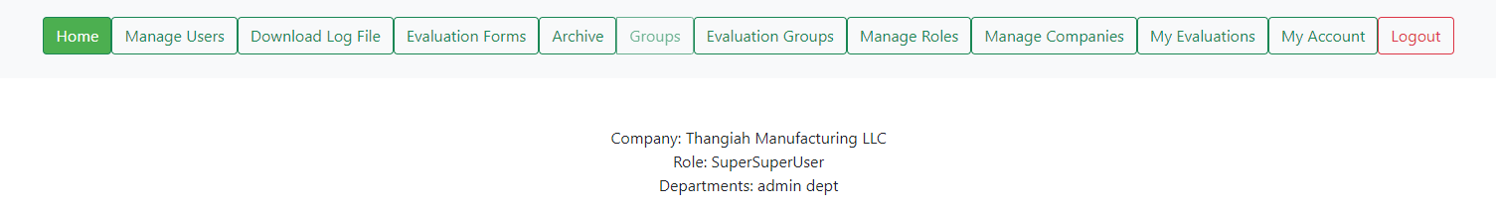

**The three buttons, noted with a red perimeter, commonly shared with all roles. The other buttons will vary depending on permissions of the user, this user is a global admin.**

# Section 2 Admin Abilities

Upon logging in, at “localhost:8080/login” or “localhost:8080/”, there are a few choices to do based on what “role” or privileges the user has. Starting with users with permission to edit, which can be accessed by the user [admin@gmail.com](mailto:admin@gmail.com), a global admin will see the following choices:

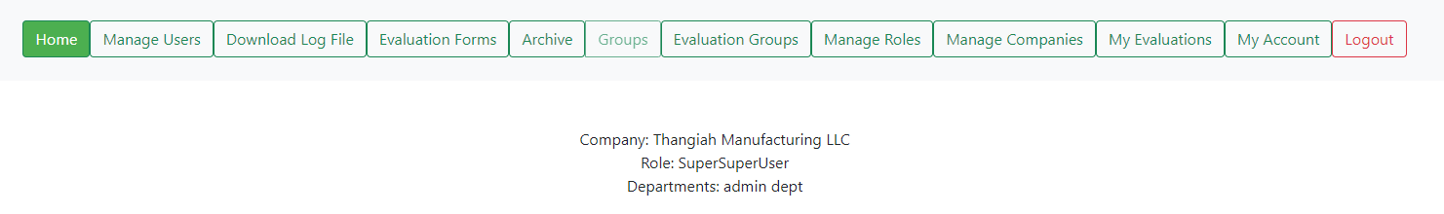

**The homepage shows the company the current user is a part of, the role of the user, and the departments the user is a part of.**

## 2.1 Adding Users

The Manage Users button will also display a webpage where the administrative user can view, edit, and delete current users within the database as well as add/upload users.

On the Manage Users button page, clicking the “Add User” button will display two things: a section with a few boxes to manually add a user new user, and a section with buttons to select and upload an excel file. A user can be created by including a first/last/suffix name, email, password, and role followed by pressing the “Add User” button. There a safe guard for signing up multiple users with the same email address so that no users may share the exact email address from here.

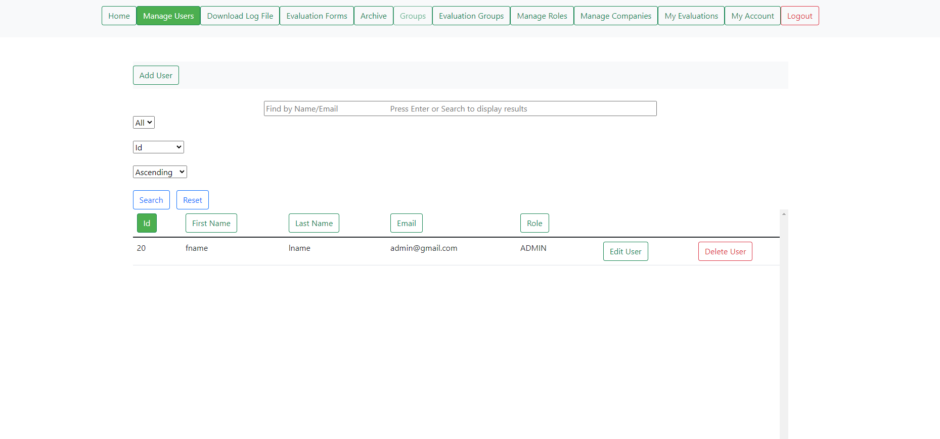

**Default view before pressing the “Add User” button**

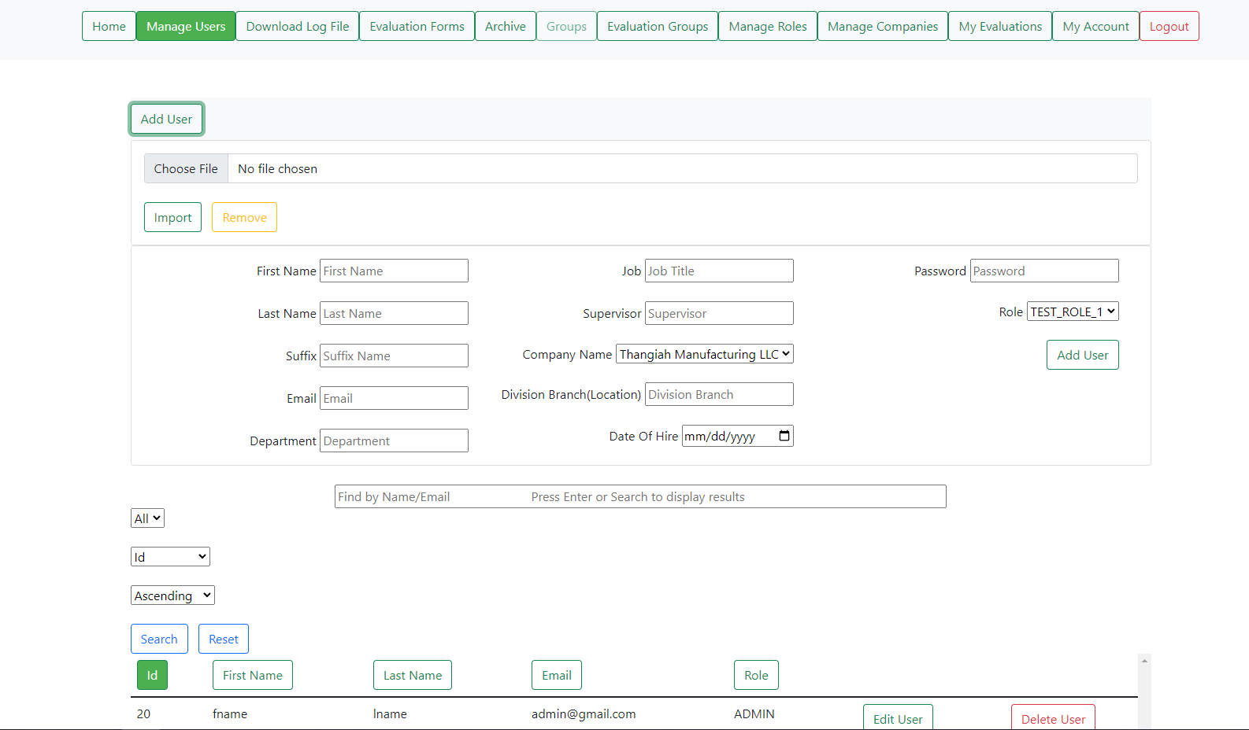

**Appearance upon clicking the “Add User” button where user details can be entered in the text boxes/ drop-down menus. The user details may attempt to be saved with the “Save User” button**

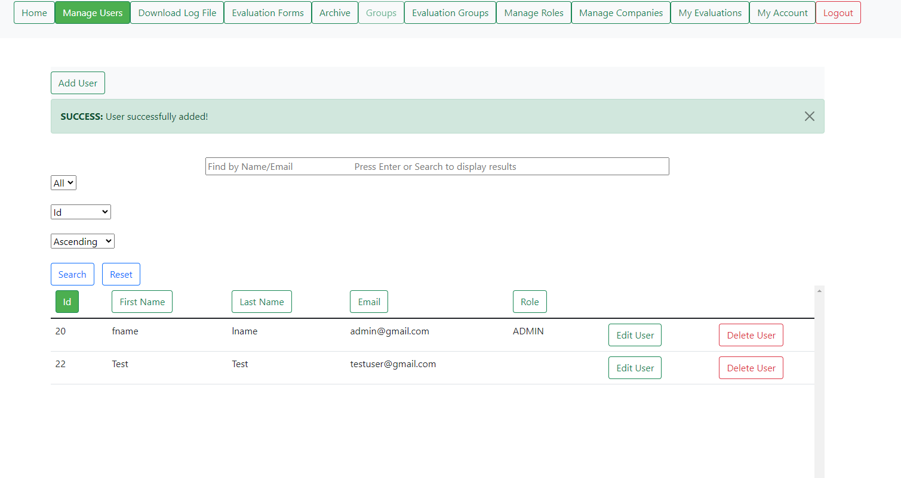

**View that’s shown when a user (being Sam Thangiah in this case) is successfully added manually once the necessary details were filled up and the “Save User” button were pressed.**

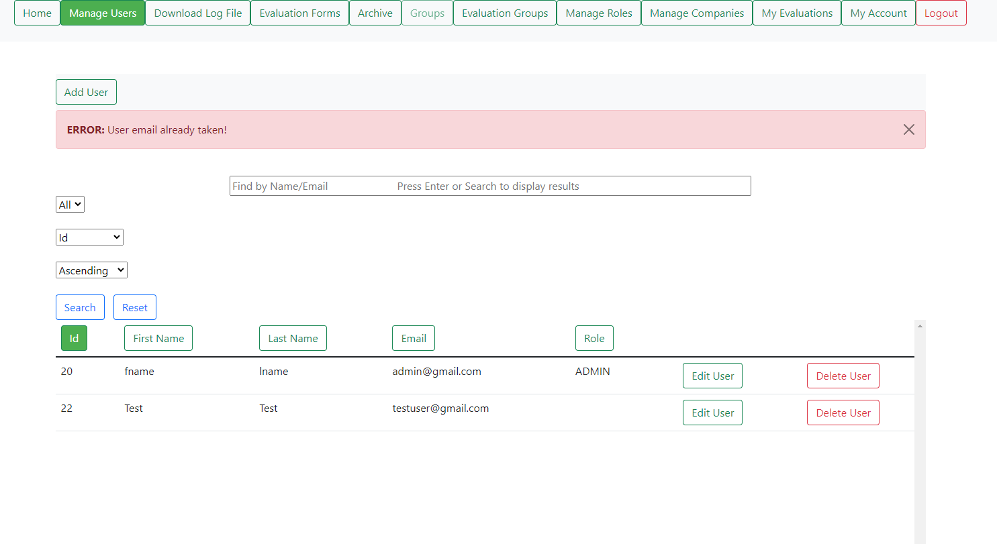**Attempting to add a new user that shares the same email as an already-existing user via the “Save User” button. Similar warning errors will display when certain, or all, fields were empty upon trying to add a user**

The “Upload Users” serves as a way to add users to the database via uploading an excel file. The file must be in particular format as can be seen in the “Documents” folder named “Review_Data_Upload_Users.xlsx”. Users may create their own version of a user upload file following the “Upload User Template Manual.docx” in the documents folder. It does check if the file is able to be uploaded as well as checks for users that are already in the database and refuses to make duplicates based on user emails. The user must click on “Choose File” and then click “Import” upon selecting a file to be uploaded. Feedback will be provided if the upload is successful or not. If a file is chosen, and the user decides that they don’t want to upload it, they may press the “Remove” button in order to deselect the file.

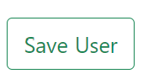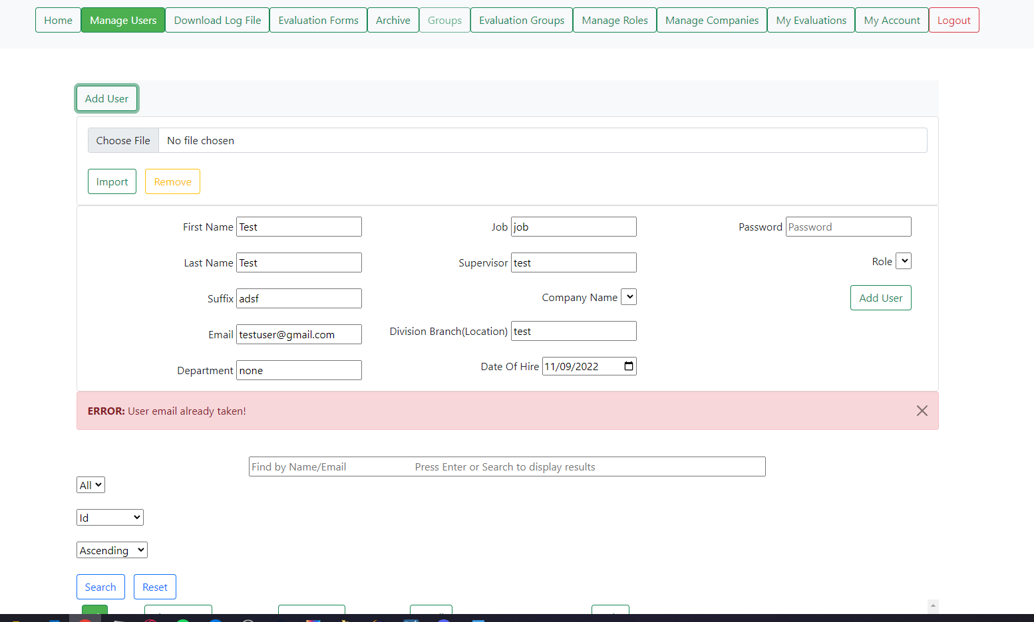

**Default appearance (with a file)**

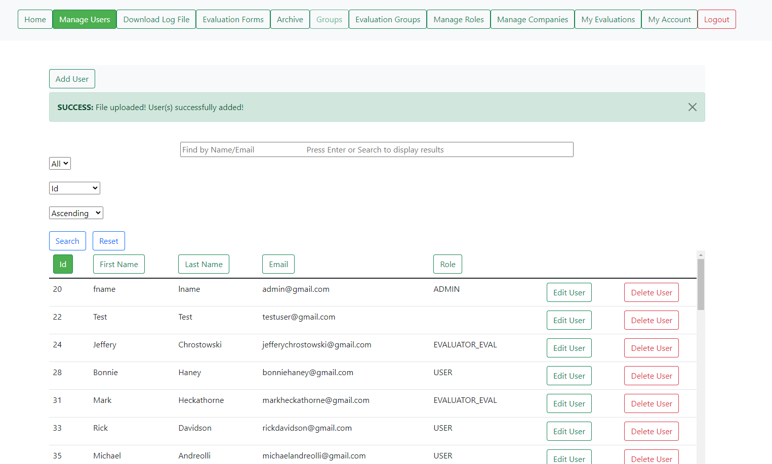

**View when users were added to the database from an appropriate file, after clicking the “Import” button**

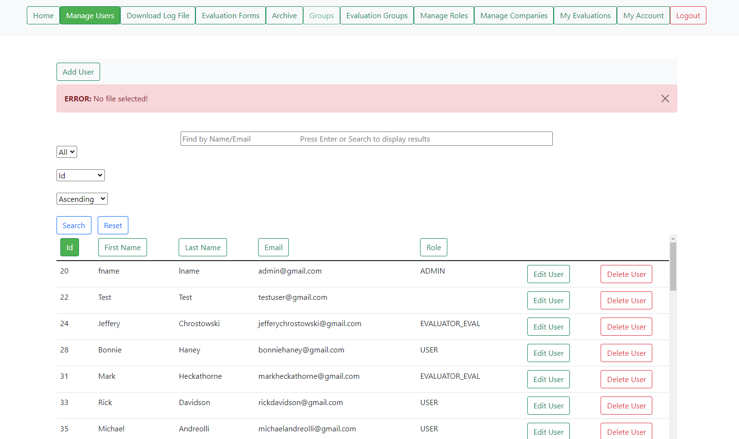

**Attempting to add new users that shares the same email as an already-existing user via the “Import” button. A similar error will pop up if the “Import” button is pressed without any files being selected**

## 2.2 Viewing the Users

After pressing the Manage Users button, the users will be able to see a table of pre-existing users with the ability to “Find by Name/Email” as well as select from drop-down menus in order to select some choices for a search. The drop-down menu on the far left directly underneath the search bar has the following choices: “ALL”, “10”, “20”, and “30”. Choosing one of those options and pressing the “Search” button under it will display the users in those respective formats. “ALL” will show all users with no restraints. “10” will display ten users at a time, where if there are more than ten users then the other users not being displayed will be viewable from clickable page links just under the search bar. “20” and “30” will do the same thing as “10” but only they’ll they display groups of 20s and 30s respectively.

The second drop-down menu, to the right of the previously mentioned one, will allow for the choice of how the list of users should be organized. The choices are by: “Id, First name, Last name, and Email”. The selected organization will provide the information in ascending order (starting from 0 or A depending on what’s being organized) and will be applied when the “Search” button is pressed or when one of the selectable buttons about each column is pressed. Once an organization method is selected and the output is provided, it’ll be indicated the drop-down box’s default option as well as the respective button, which will be filled in, above the column it represents.

A Third drop-down menu can be found under the search bar, set to the far right where the options of sorting the list of users in either ascending or descending order.

Clicking on buttons such as an “Edit User” or “Delete User” will maintain the users per page count and the sort type. Both tidbits of information are only maintained until leaving the Manage Users page.

The search bar allows the user to populate it with the characters, terms, or names that the user wishes to search for. The “Search” button must also be pressed when searching for a user. The currently-selected user-per-page and sorting value selected will be applied to any searches done. The “Reset” button will display all users on one page.

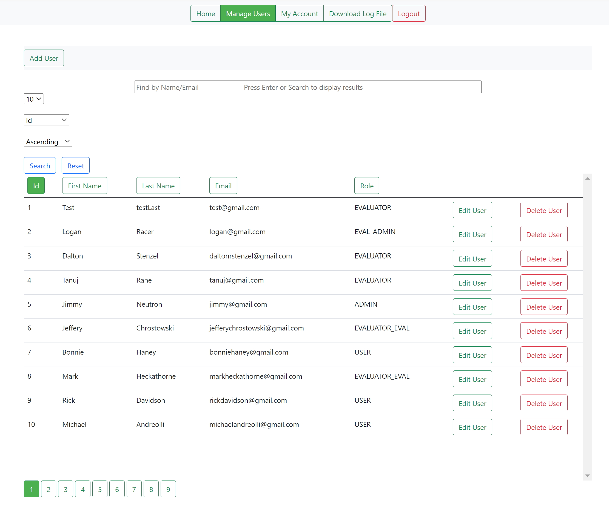

**View of seeing ten users at a time with ascending Ids (Post uploading users in Section 2.1)**

## 2.3 Editing Existing Users

Clicking on “Edit” beside any user under the users table will provide a page where the selected user can have their first/last/suffix name, email, job, supervisor, company name, division branch, date of hire, password, and role changed and saved upon entering and selecting the respected values and submitting the changes with the “Update User” button. Feedback will be provided depending on whether the change was successful or not.



**Default view before pressing an “Edit User” button**

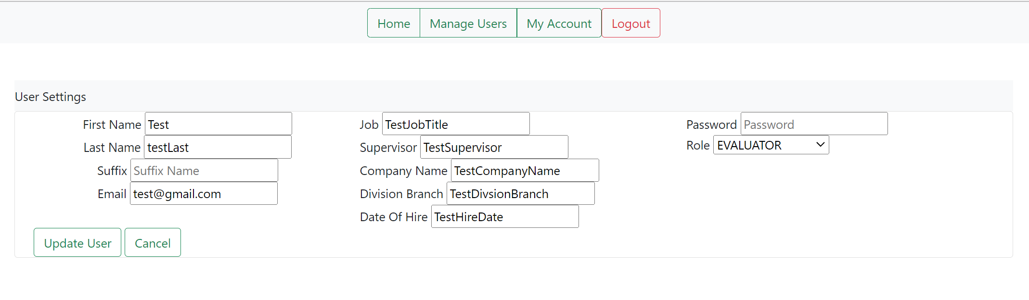

**Default view after pressing an “Edit User” button**

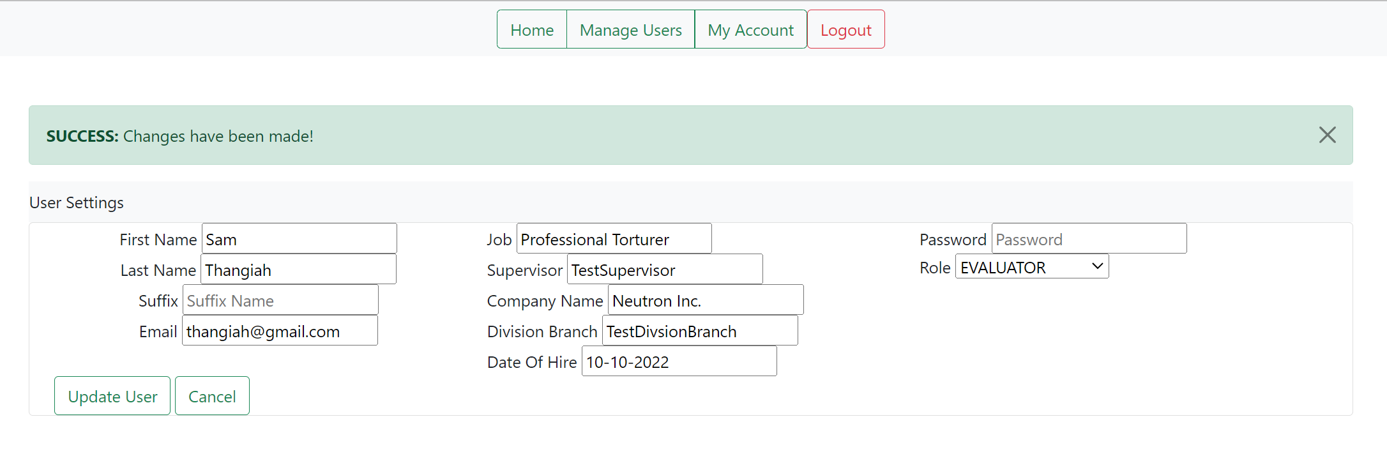

**View when changes were successful**

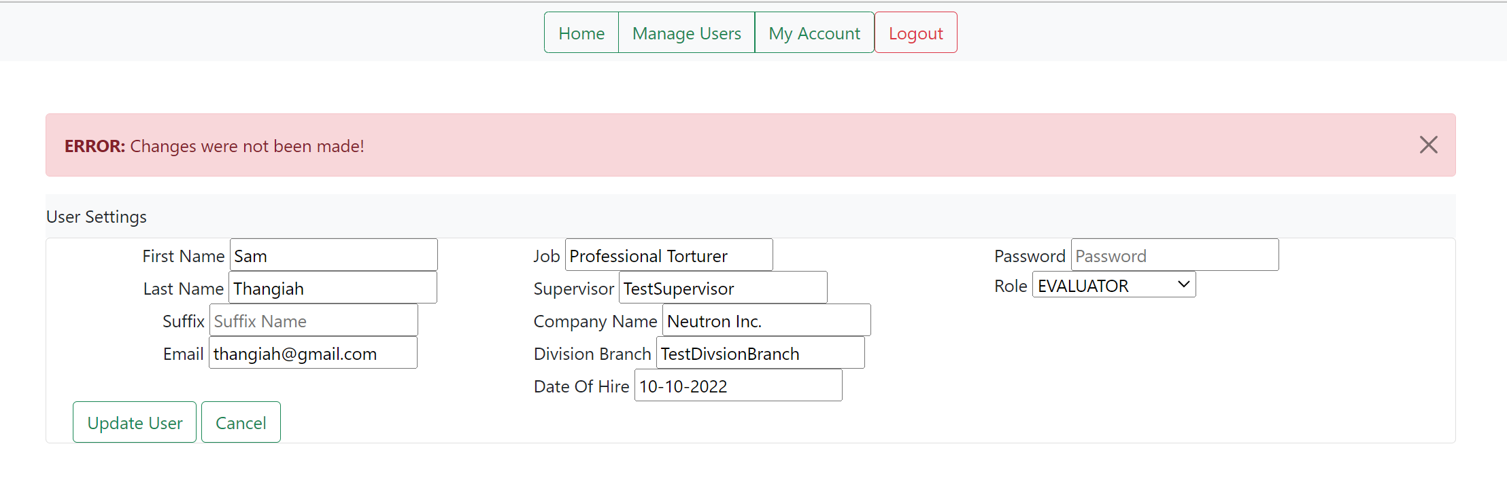

**View when changes failed to occur**

## 2.4 Deleting Existing Users

Upon returning to the previous page with the Users button in the navigation bar or the “Cancel” button on the editing page, the “Delete” button will delete a user as long as they’re not a part of group yet.

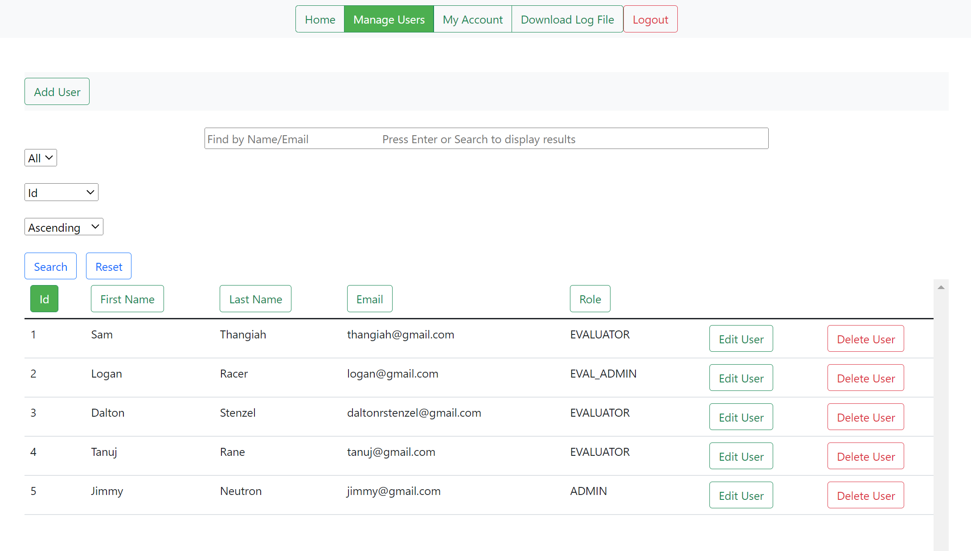

**Pre deletion**

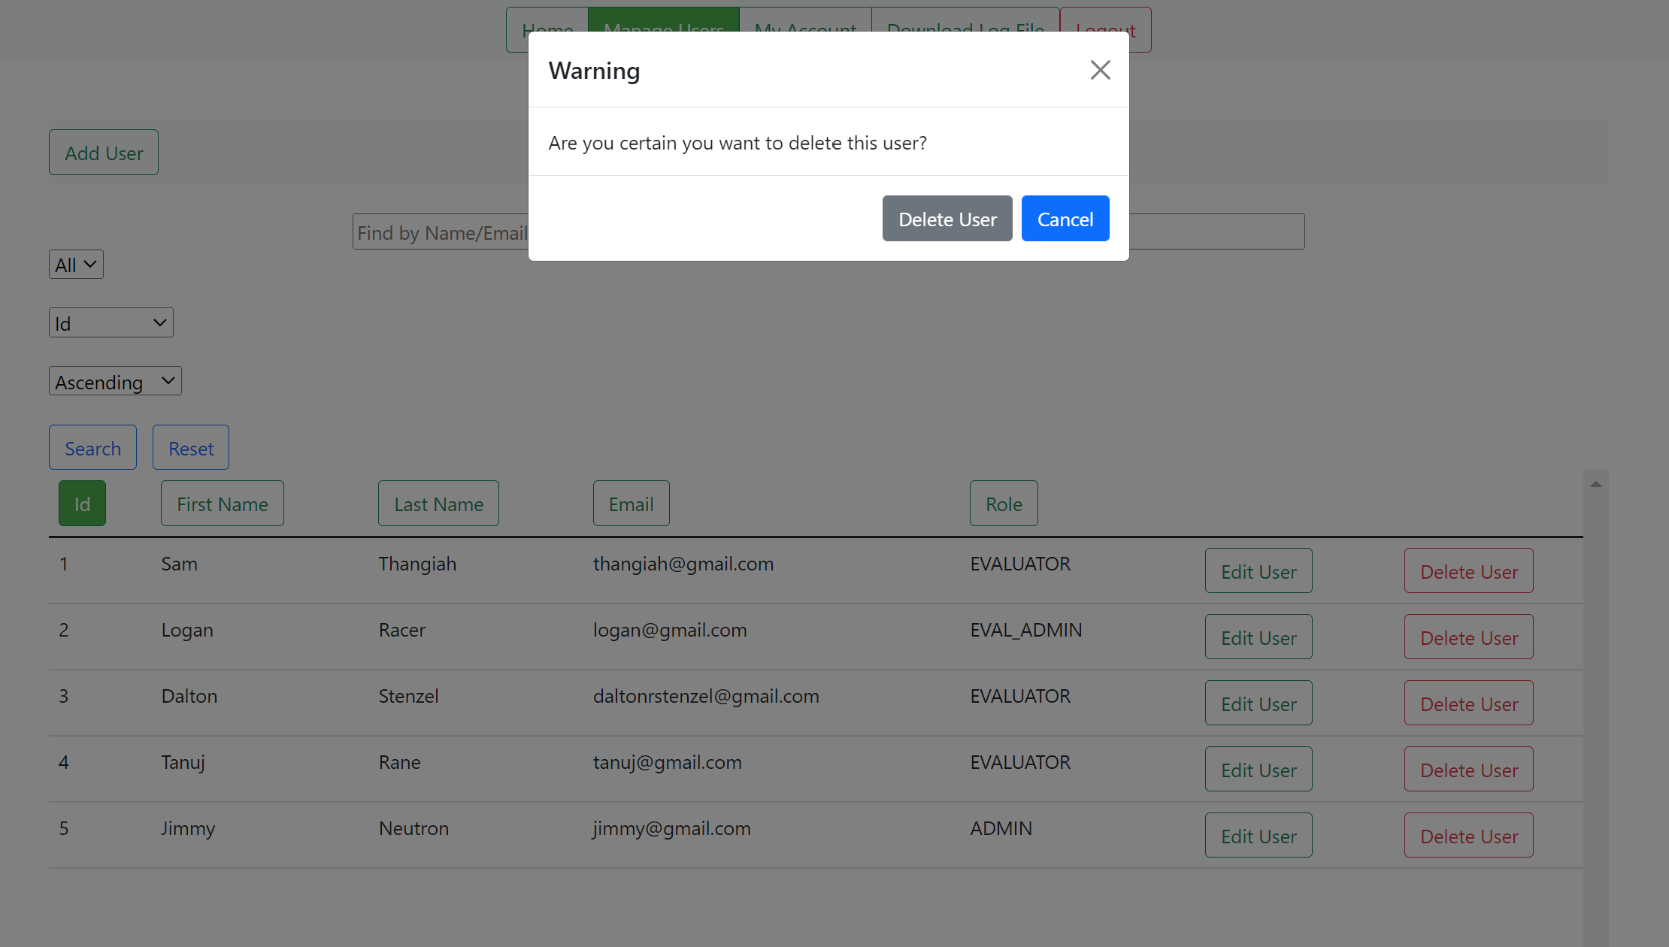

**View upon clicking a “Delete User” button**

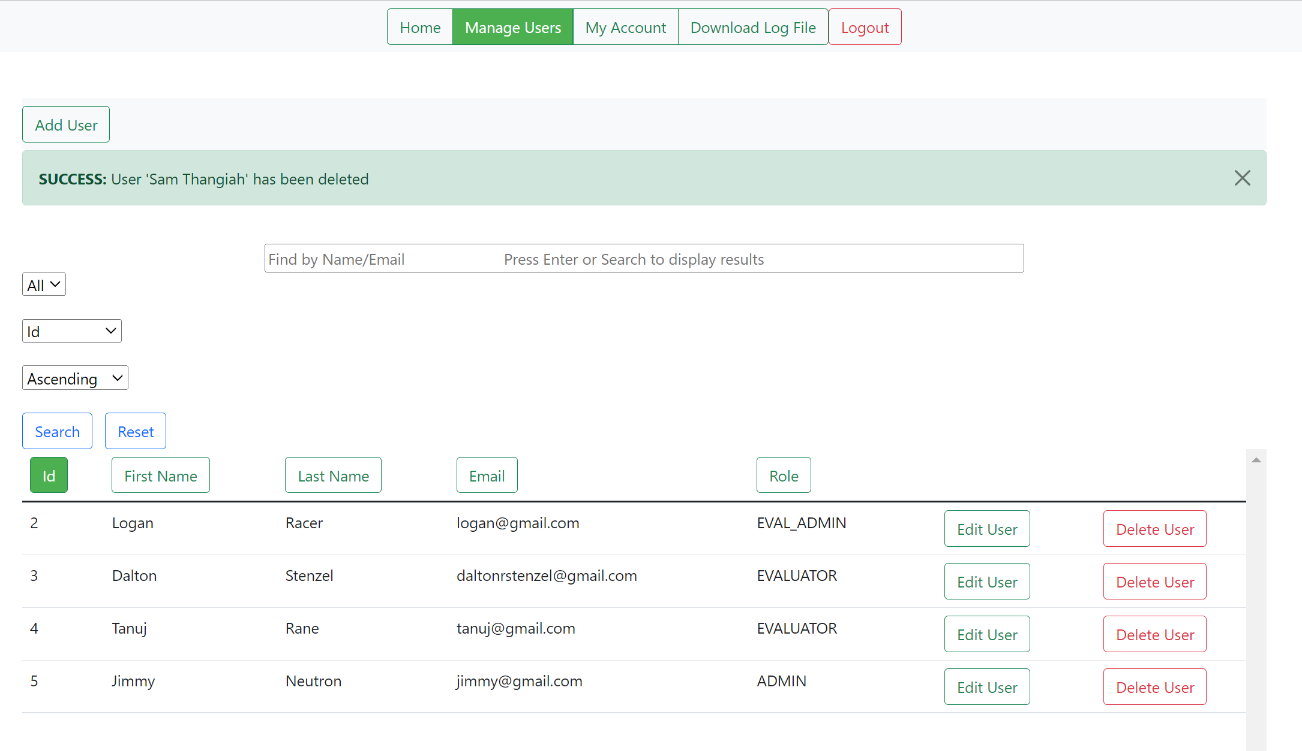

**Post deletion**

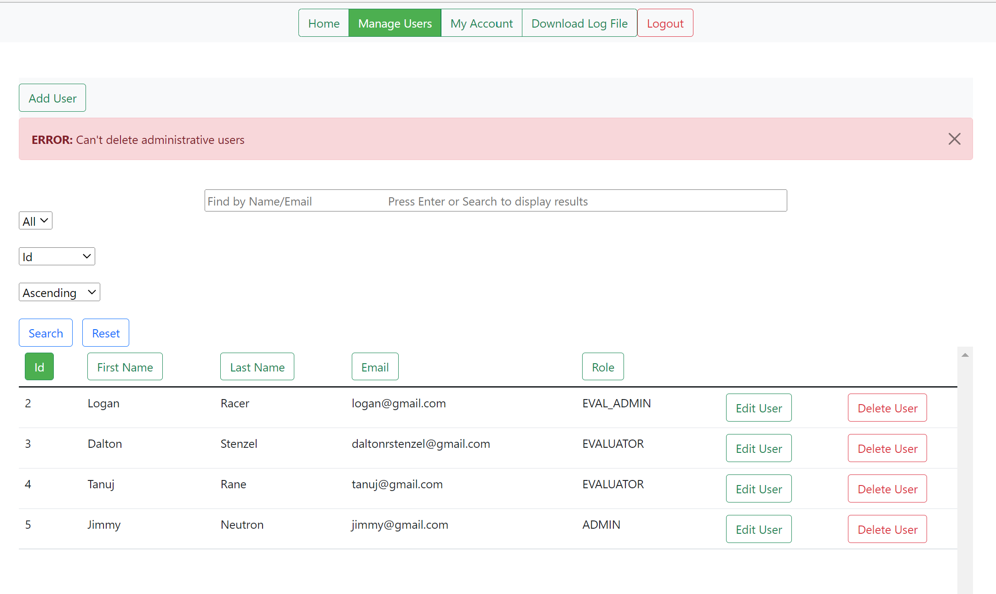

**Post deletion attempt on another user with the “ADMIN” role**

## 2.5 Adding Company

If the user is a super user then they will have access to the manage companies button. From this page they will be able to upload companies to be added to the database. This will include the locations in the company, company name, departments in the company, and which departments are in which location(s).

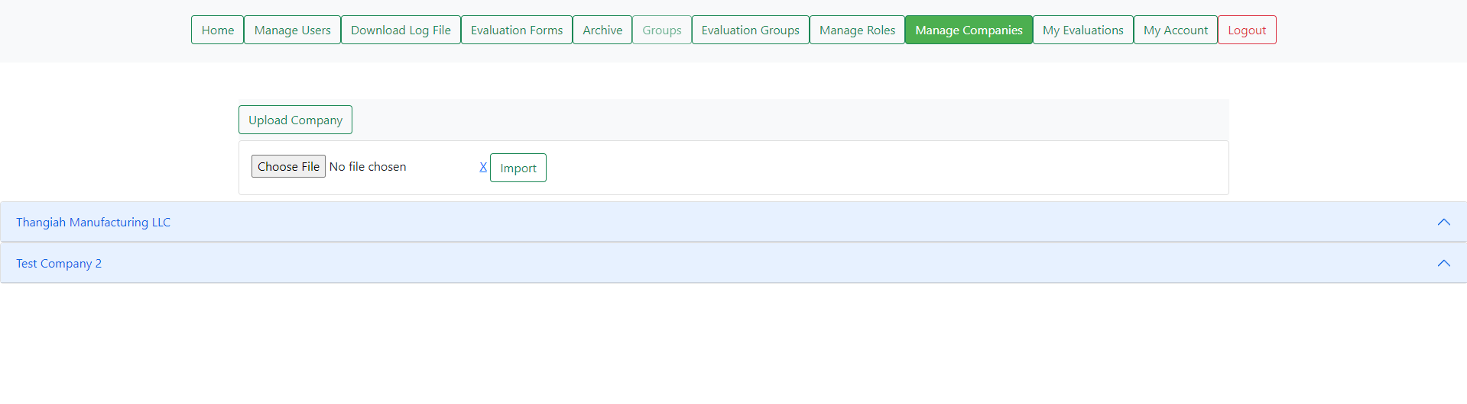

**Default view for manage companies**

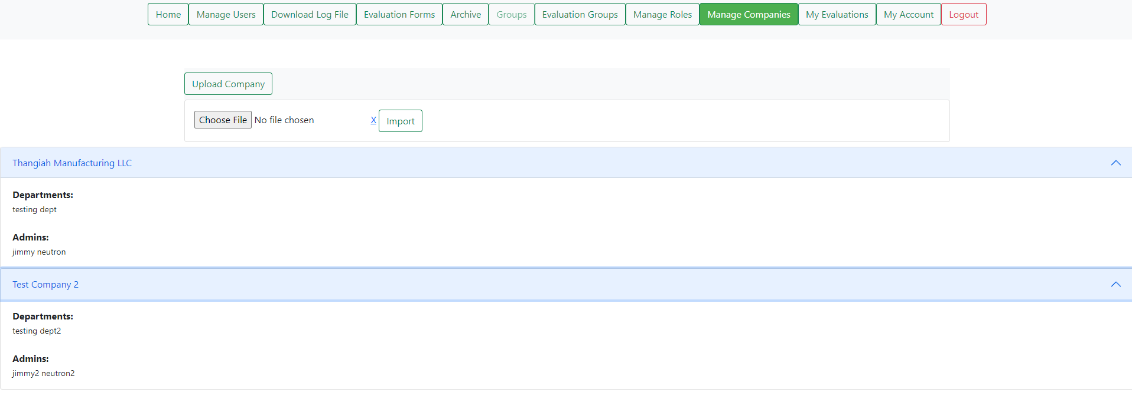

**View with companies expanded to show info.**

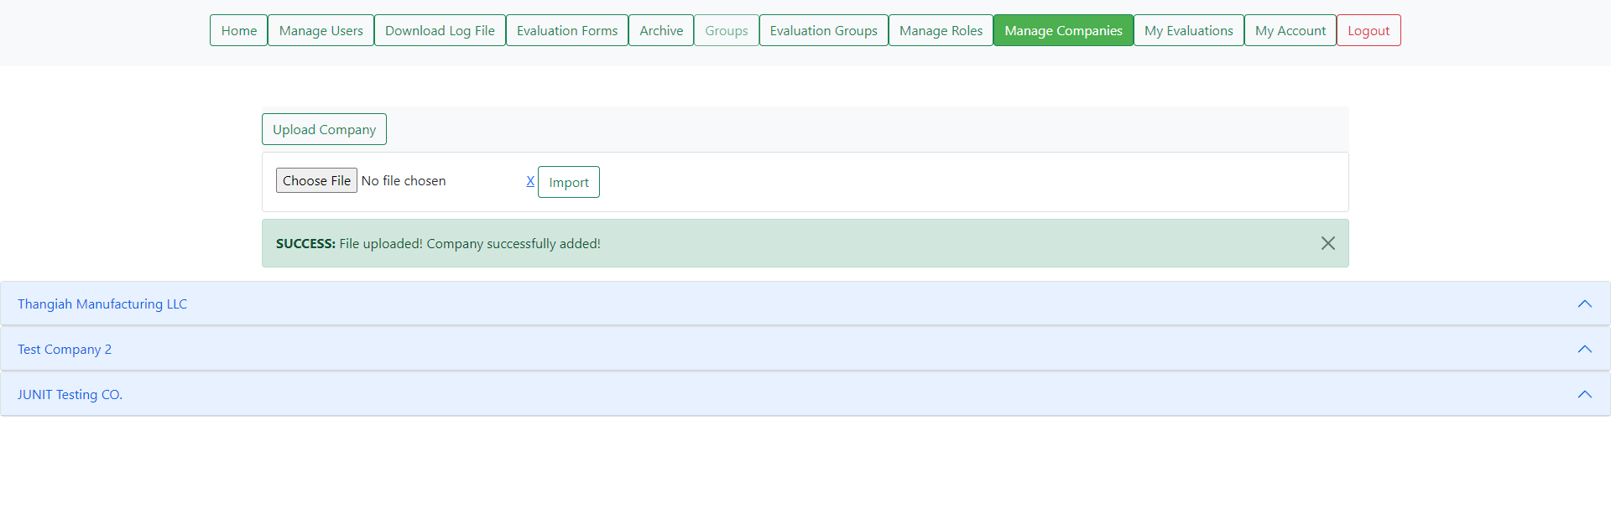 **View after uploading a file.**

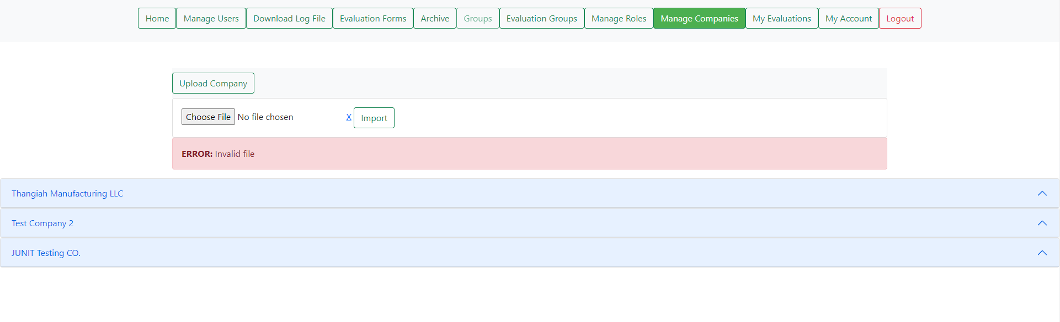

**View for if you upload the wrong file or don’t add a file.**

## 2.5 Adding Roles

If the user is a company super user they will have access to the manage roles tab. In this tab they will be able to view the roles existing within the company and add more via excel template upload. The roles will contain the role names as well as the privileges of each role. All of this will be saved and can be reused later. The roles can be expanded to show the departments they have privilege over as well as the privilege names associated with them.

NOTE: it is only accessible to one company.

NOTE: You will need to make sure that all locations/departments are created before assigning them to roles.

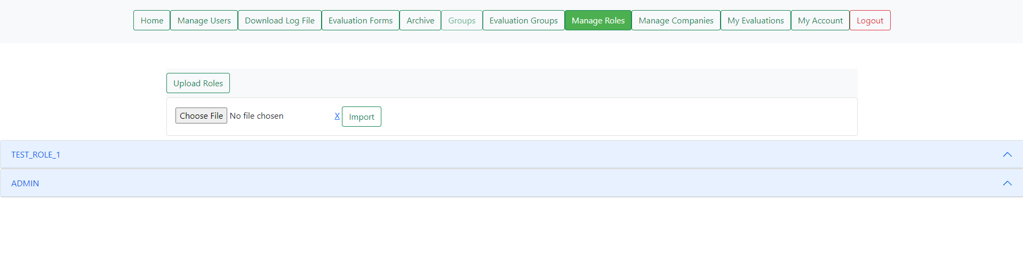

**Default view for manage roles.**

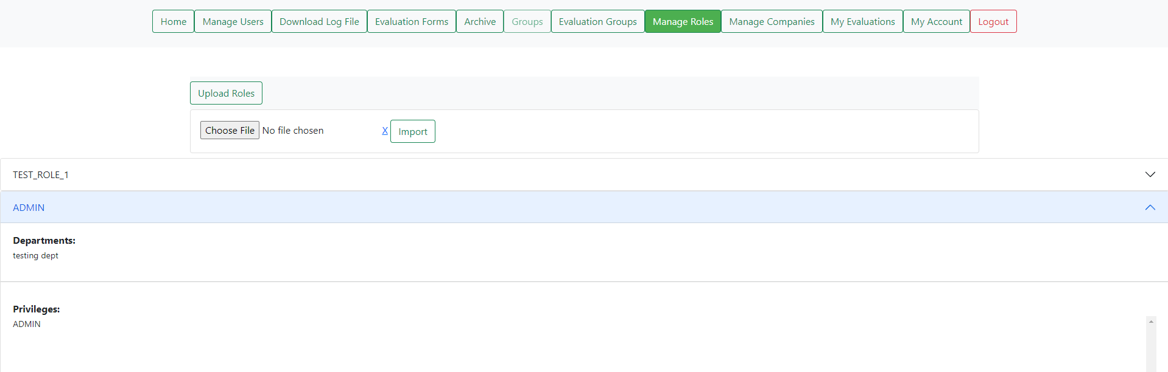

**Expanded view**

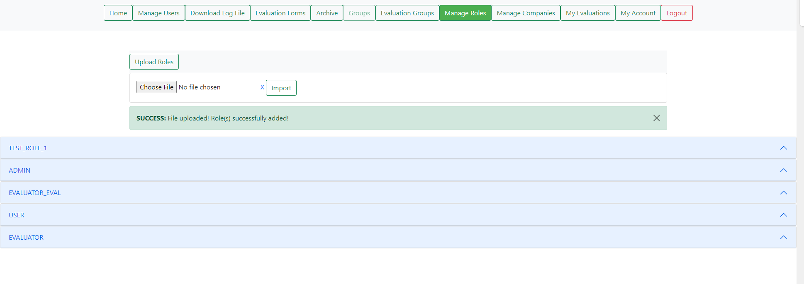

**View after successful upload of roles.**

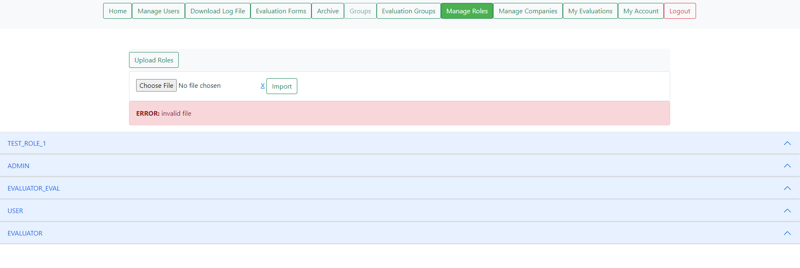

**View if you upload wrong file or no file.**

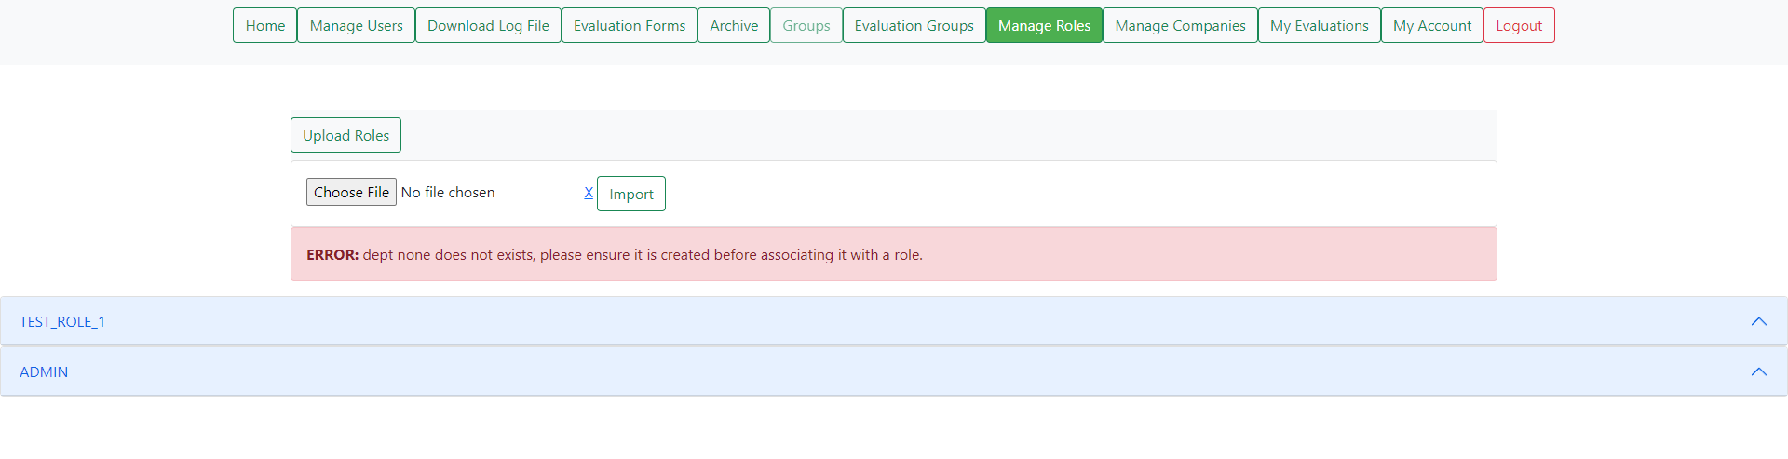

**View if you have not created the resources the template is referencing**

# Section 3 Evaluator Admin Abilities

By default, the database does not come with a user with the role “EVAL_ADMIN”/ evaluator admin role so the administrator must create one following the Section 2.1 on adding users in order to follow the examples below.

## 3.1 Evaluations Form Navigation Bar Options

A user with the role “EVAL_ADMIN” must be created here in order to view the content below. Once an evaluator admin has been created, they will see that, upon logging in, that the Home button serves the same purpose as it does for those with the “ADMIN” role, which brings you to the home page, which is the exact page a user sees upon logging in. A button in the same general area/row that will be covered next is the Evaluation Forms button. That button links to a page with the ability to “Upload New Evaluations”.

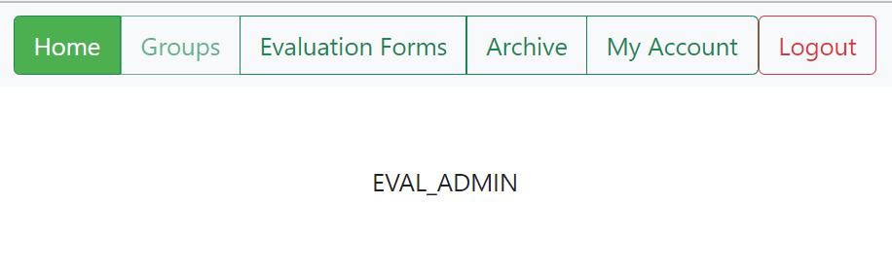

## 3.1.1 Uploading a New Evaluation

Upon clicking the Evaluation Forms button and being redirected to a new page, a section will be viewable that’ll allow an evaluation template to be chosen and uploaded with the “Choose File” and “Import” buttons respectfully. Multiple files can be uploaded in a linear fashion. The file to be uploaded must follow the proper format to be interpreted and displayed on the page. Example excel documents will be provided in the “Documents” folder with the prefix “Upload Evaluation – EVAL –“where the three with “001”, “002” and “003” must be uploaded. The “001” file with errors in the title is for demonstrating what can occur if there are problems with the file. The “002” file contains non-critical errors but can still be uploaded. Any excel file which follows the format can be uploaded, allowing for customized evaluation questions to be used. Refer to “Evaluation Template Manual.docx” in the “Documents” folder to see instructions for creating a customized evaluation template document.

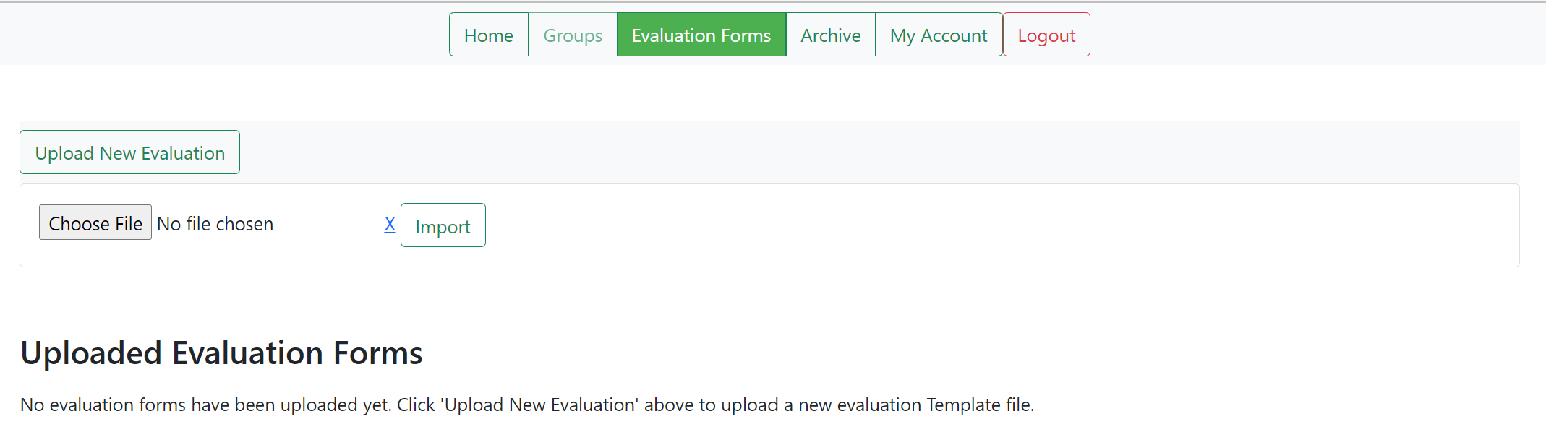

**Default view**

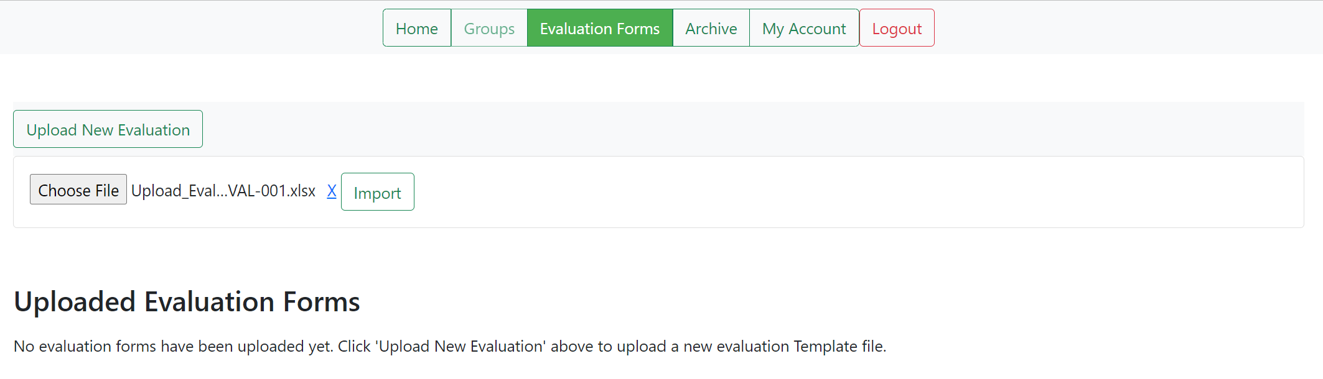

**Default view (with a file selected)**

A file can be removed after being selected, but before being imported via the “Import” button, by pressing the “X” button to the left of the “Import” button. Clicking “Import” will save the template to be used for evaluations and the webpage will display a text signifying that the upload was successful as well as a preview of the file chosen. The preview can be removed by pressing the “Toggle Preview” button.

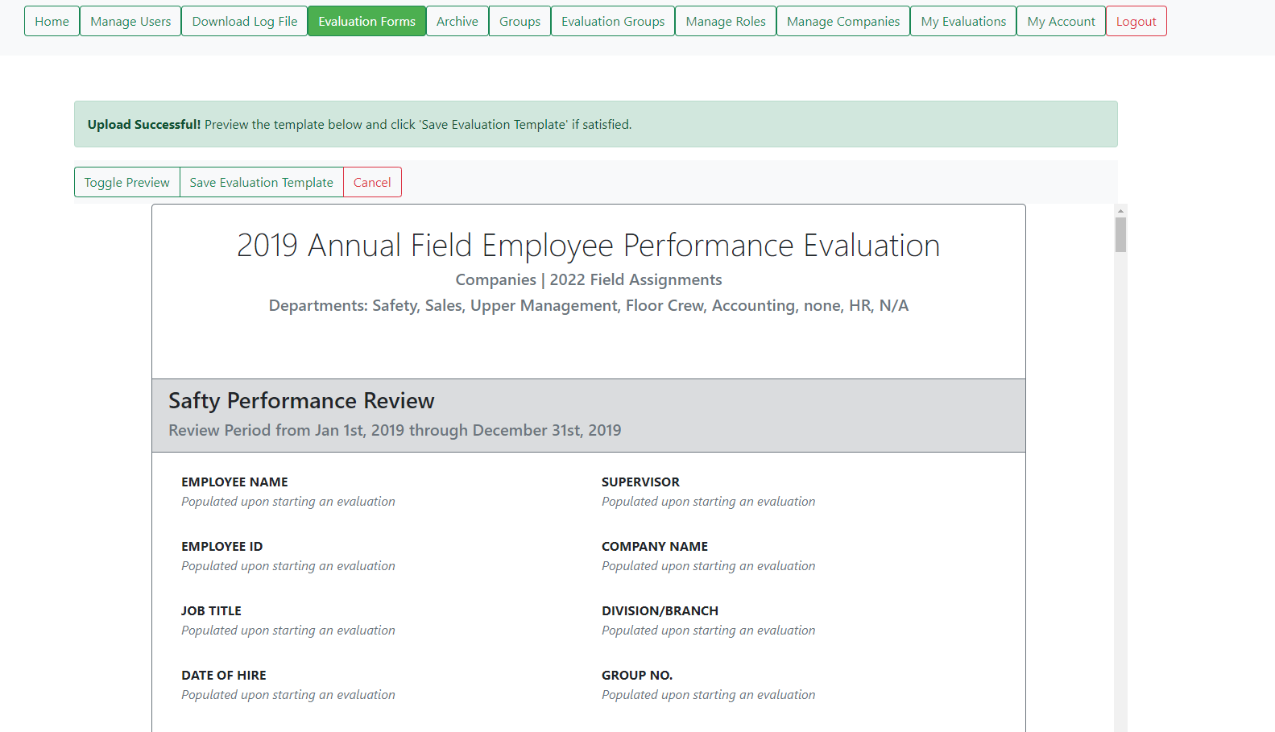

**View after selecting a valid evaluation form and pressing “Import”**

In order to use the chosen evaluation form, you must press one of the “Save Evaluation Template” buttons either above or below the preview.

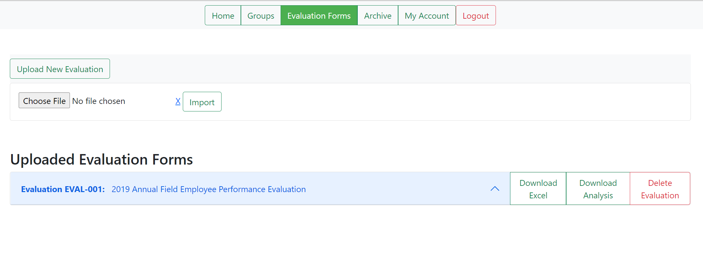

**View after clicking the “Save Evaluation Template” after importing an evaluation file.**

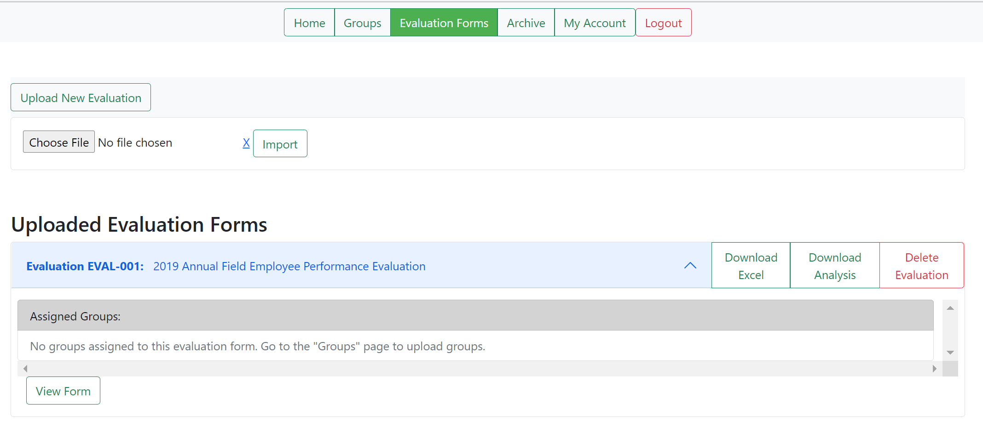

**View after pressing the drop-down button named after one of the evaluation files saved, located directly under “Uploaded Evaluation Forms”**

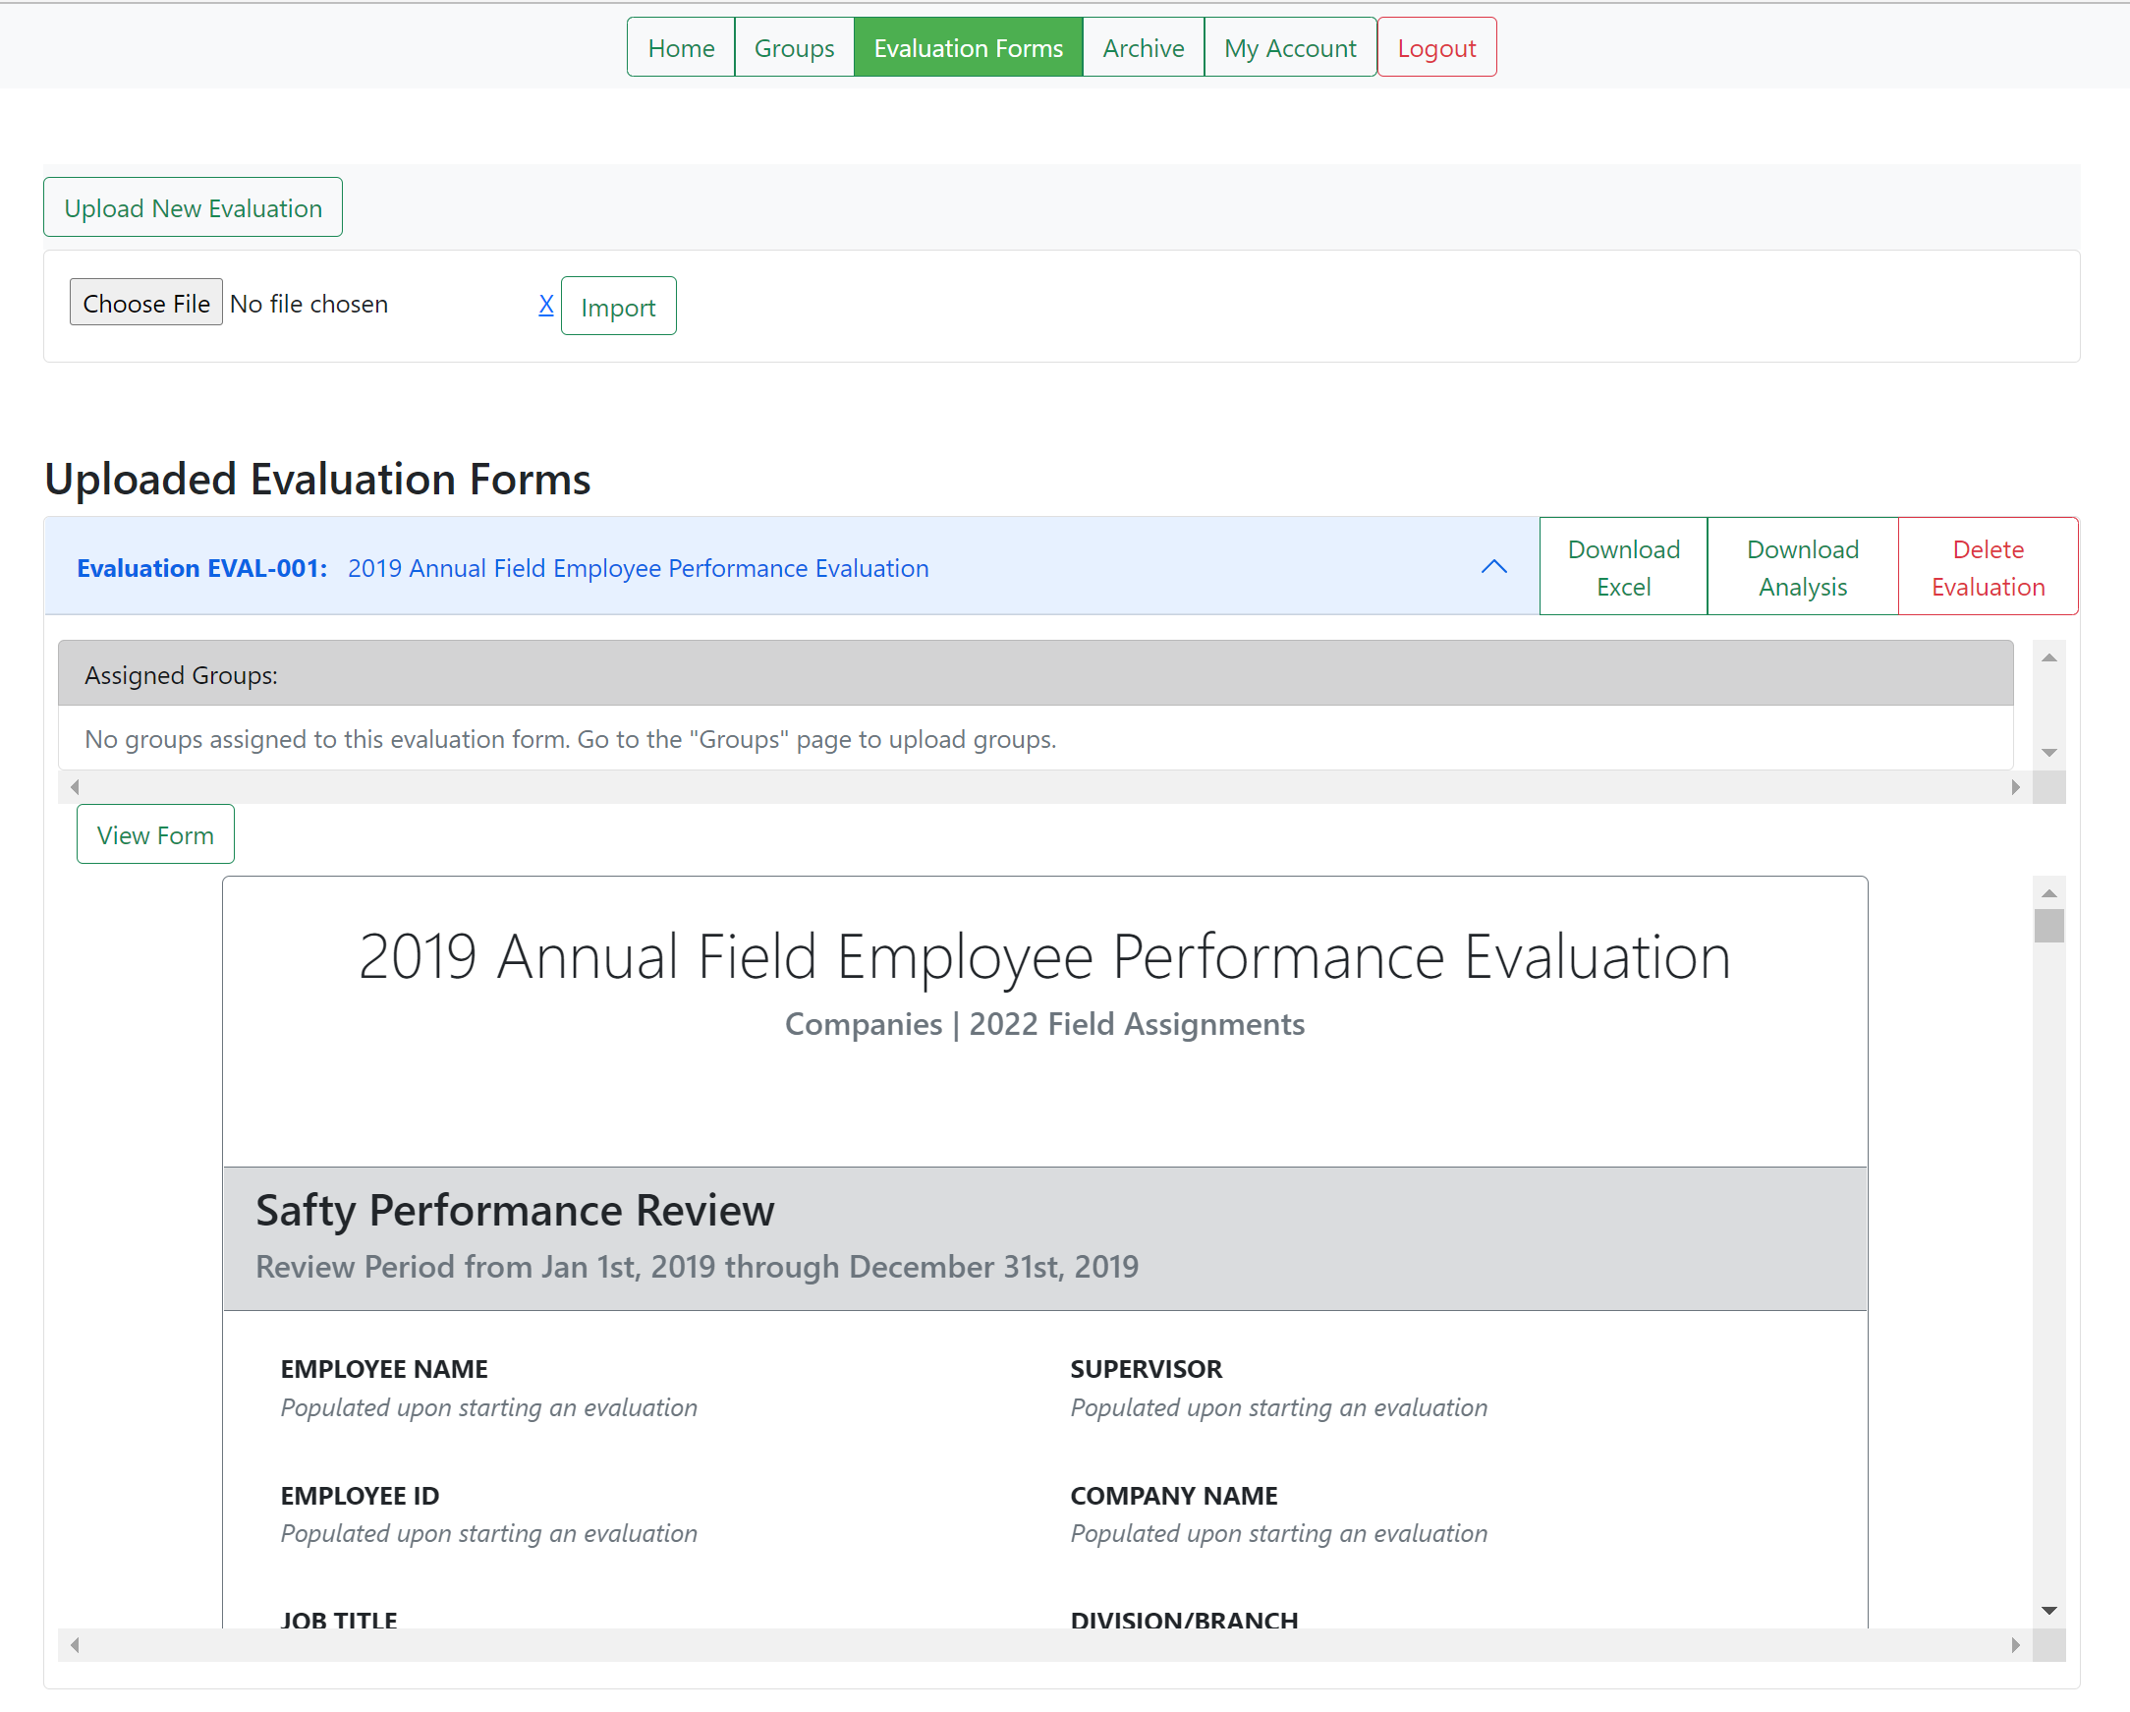

**View after pressing “View Form” located in the drop-down menu of on the of the user’s saved evaluation forms**

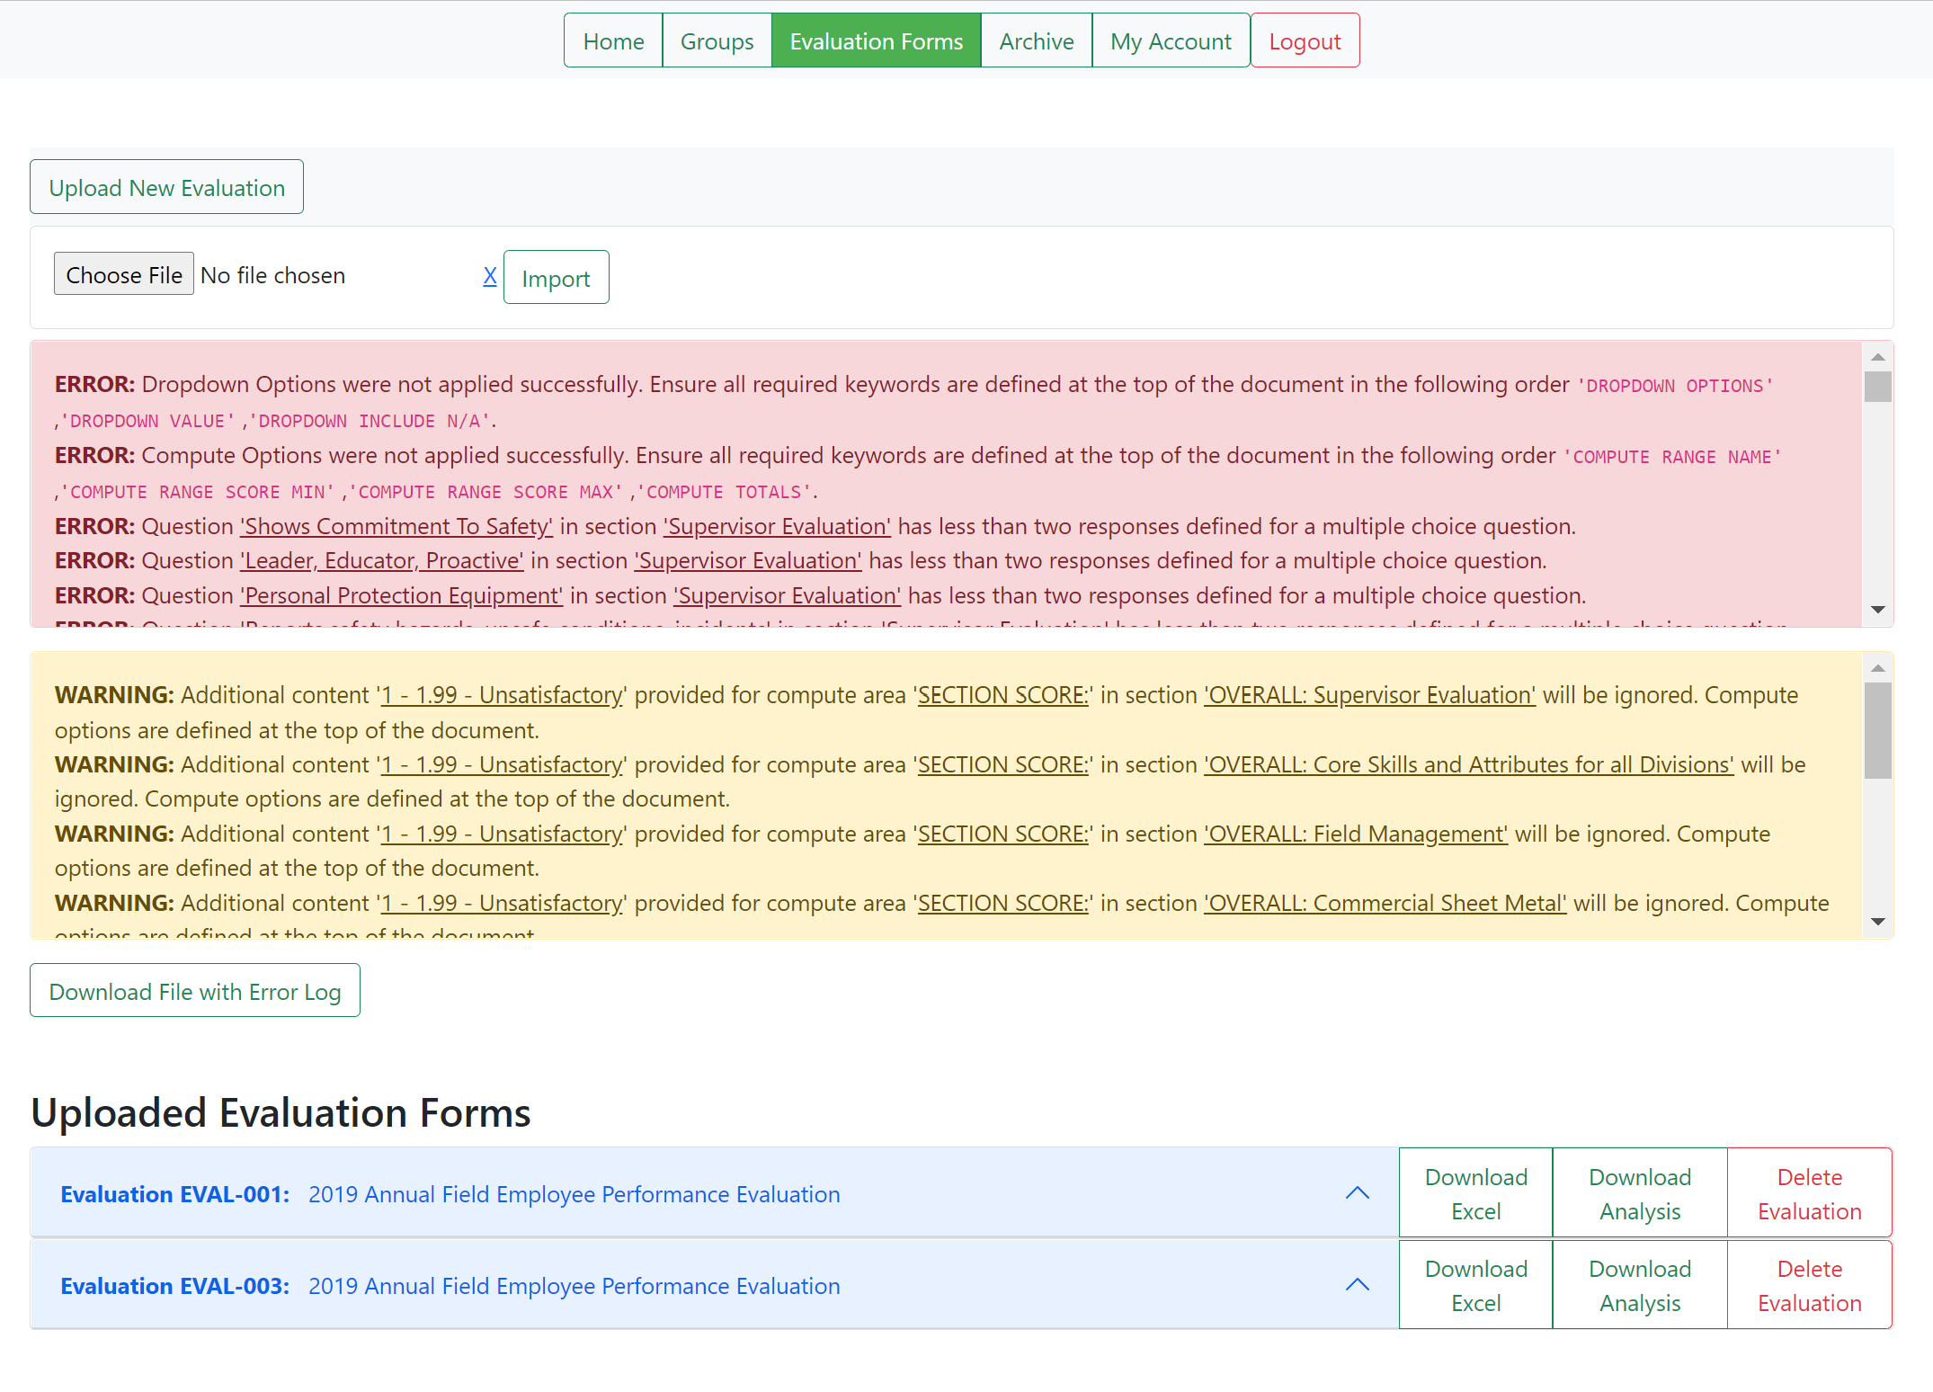

**View after attempting to import an evaluation form with problems**



**Partial view of the error log attached to the second sheet of the file retrieved from the “Download File with Error Log” button**

## 3.1.2 Downloading an Evaluation Analysis



Upon uploading users, evaluation forms, and groups and performing at least one evaluation, an “EVAL_ADMIN” may press “Download Analysis” on an evaluation form in order to see a performance score from the given questions in a form. If there are no evaluations done using a form, then there will be no scores displayed in the form’s analysis.

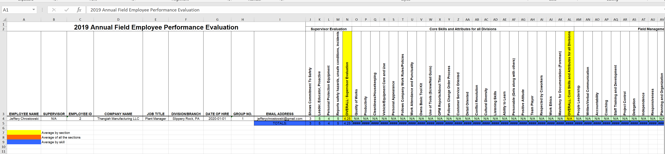

**The fractional pre-evaluation view of the other sheet located in the file obtained from the “Download Analysis” button mentioned previously. This sheet example has a single evaluation done with this particular form.**

## 3.1.3 Deleting Evaluation Forms



Admin_Evals have the option to delete evaluation forms if they’re not assigned to any groups. If there are groups assigned to the particular form upon trying to delete it, then the button will be disabled and a note will notify the user that the form is in use. Otherwise, a form may be deleted.

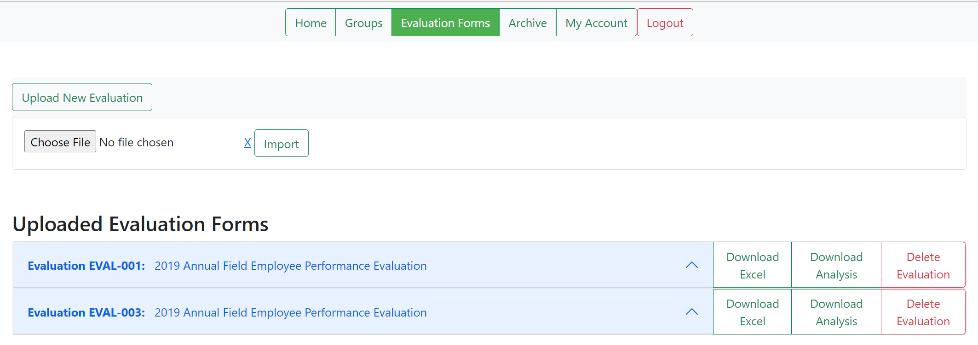

**Default View**

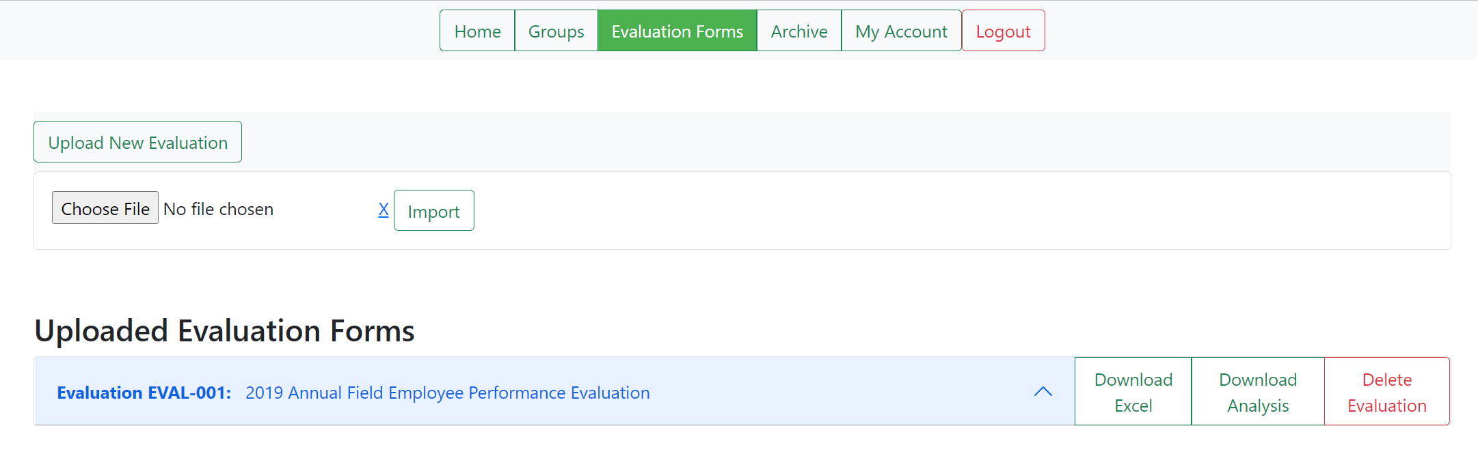

**View after deleting EVAL-003**

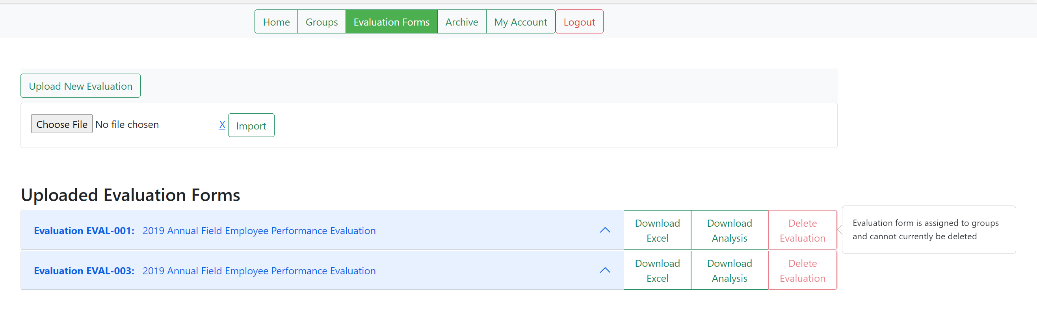

**View upon trying to delete an evaluation form if the form is assigned to a group**

## 3.2 Groups Navigation Bar Options

The Groups button brings the options to “Add Group”, “Edit Group”, and “Remove Group”, though only the former option is visible until groups are present.

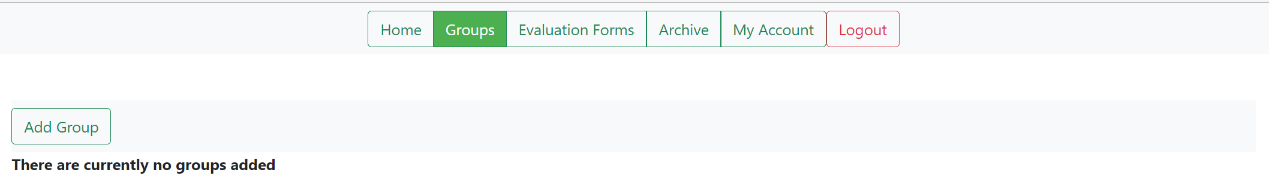

**Default view**

## 3.2.1 Groups Button: Adding Groups

The “Add Groups” button will display a section that allows for a file to be selected and uploaded, from the “Choose file” and “Import” buttons respectively, in order create groups from a given excel file that is properly formatted. An example will be provided in the “Documents” folder called “Review_Data.xlsx.

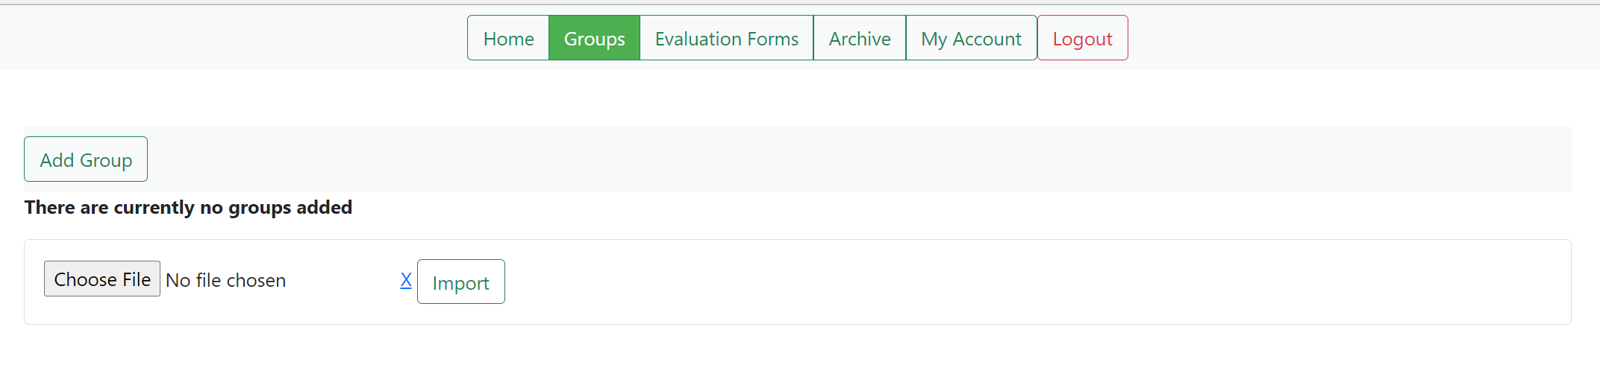

**View upon pressing “Add Group”**

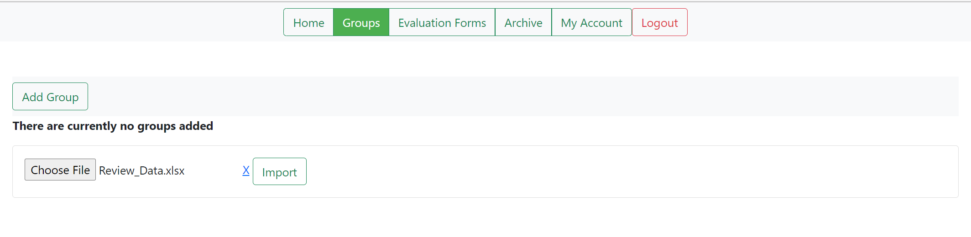

**View upon pressing “Add Group” & choosing a file**

Upon uploading a group from the “Import” button, groups should then populate the webpage, as long as the users for the respective groups are present in the database. If the user(s) do not exist, then no groups will be created.

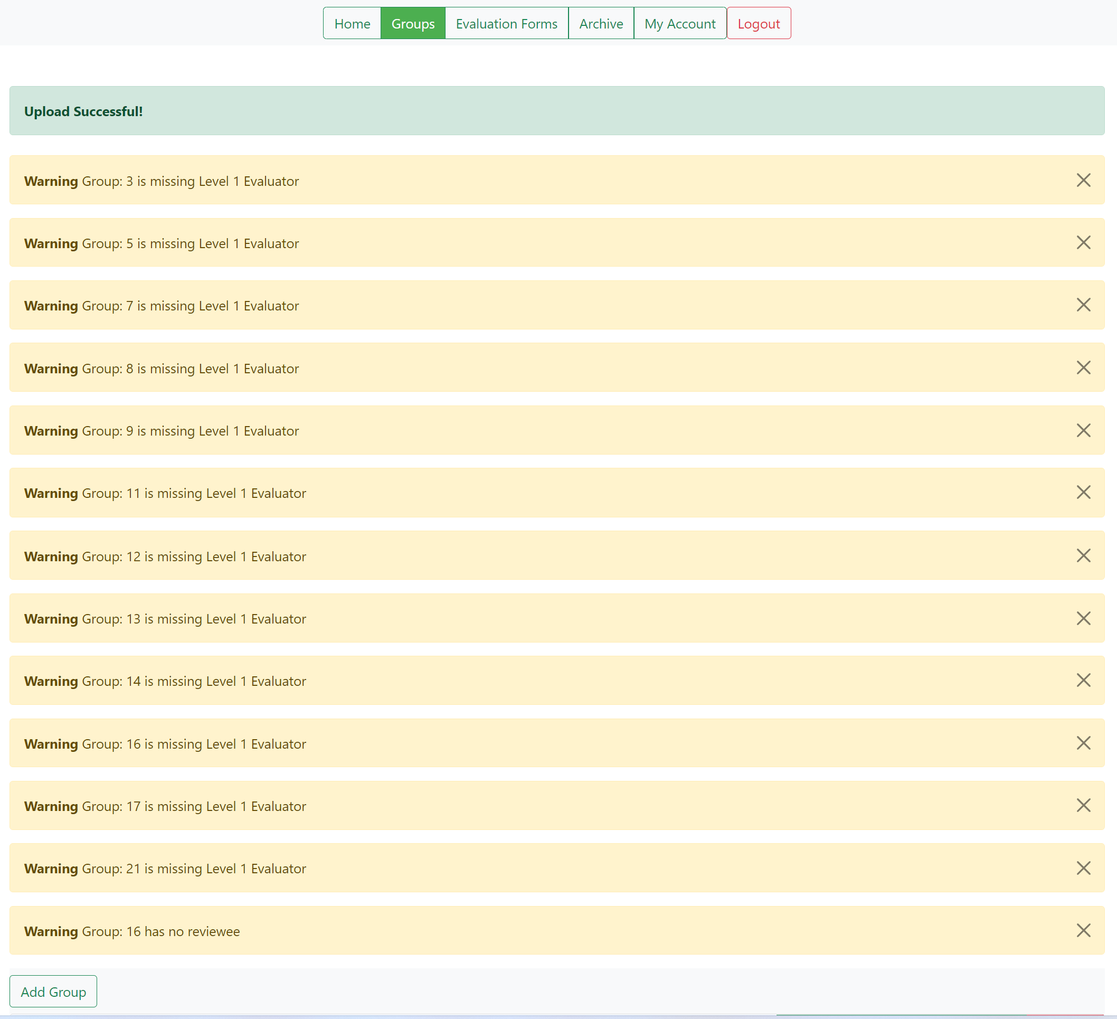

## 3.2.2 Viewing Groups and Previewing Evaluations

Pressing on a group will then display the inhabitants and their respective roles for the selected group.

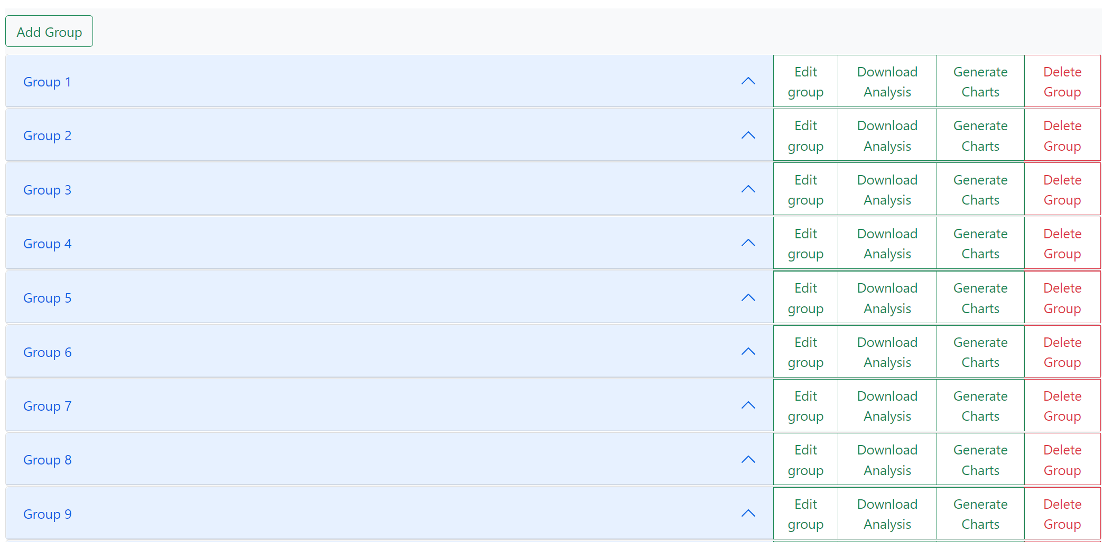

**Default view**

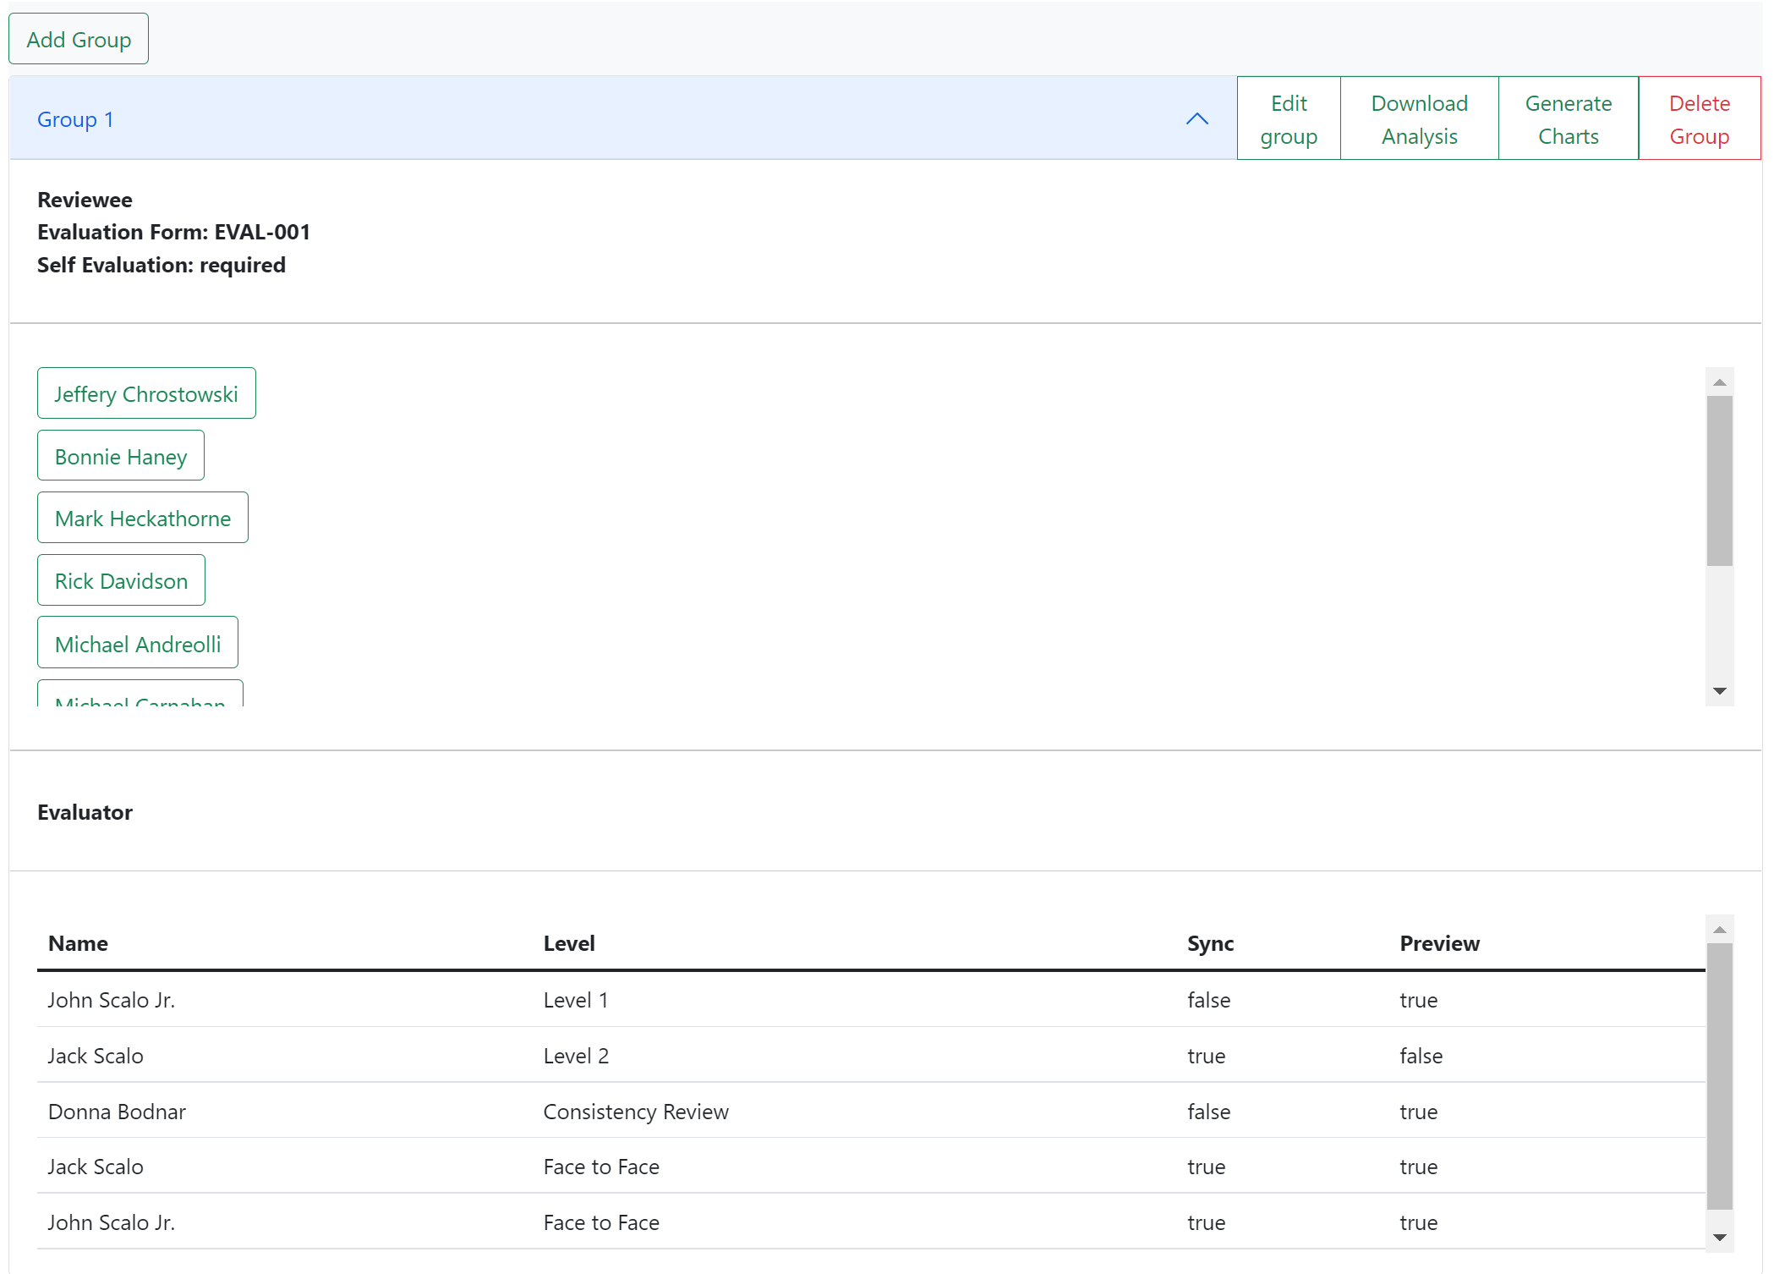

Information that is viewable upon opening up a group includes “Reviewees” and “Evaluators”. The reviewee’s section includes buttons made from the names of each reviewee that’ll take the evaluation administrator to a page retaining the evaluations done on the selected user. The evaluator section includes a table consisting of columns named: “Name”, “Level”, “Sync”, and “Preview”.

The former two note the name of the evaluator and what type of evaluator they are. “Sync” denotes some amount of order for evaluations. A “false” means “no order” to evaluation level that come after while a “true” states that evaluations of a single level higher must wait until the evaluation is completed in order to progress.

In the case from the screen capture above, the levels consist of Level 1 < Level 2 < Consistency Review < Face-to-Face. John Scalo Jr. may proceed with his Level 1 evaluation at any time as there are also no evaluations that need to be done that are deemed a lower level. Jack Scalo may also do his Level 2 evaluation at any time as John has a “false” for his Level 1 Sync value. Jack could do his Level 2 evaluation before John completes his Level 1 evaluation. Donna Bodnar must wait for Jack to have his Level 2 as Jack’s Level 2 evaluation contains a “true” value. John and Jack may proceed with their Face-to-Face evaluations once they’ve completed their Level 1 and Level 2 evaluations respectively as there isn’t a “true” value associated with Donna’s Consistency Review Sync value.

Pressing on a user in a group will lead to a page where evaluations on the user may be viewed. Upon clicking an evaluation to preview, an ability to download any files attached to the evaluation will be present with a “download” button. It’s very similar to the ability users with the “Evaluator” role has, except an evaluator might have viewing restrictions on other evaluations done by other evaluators.

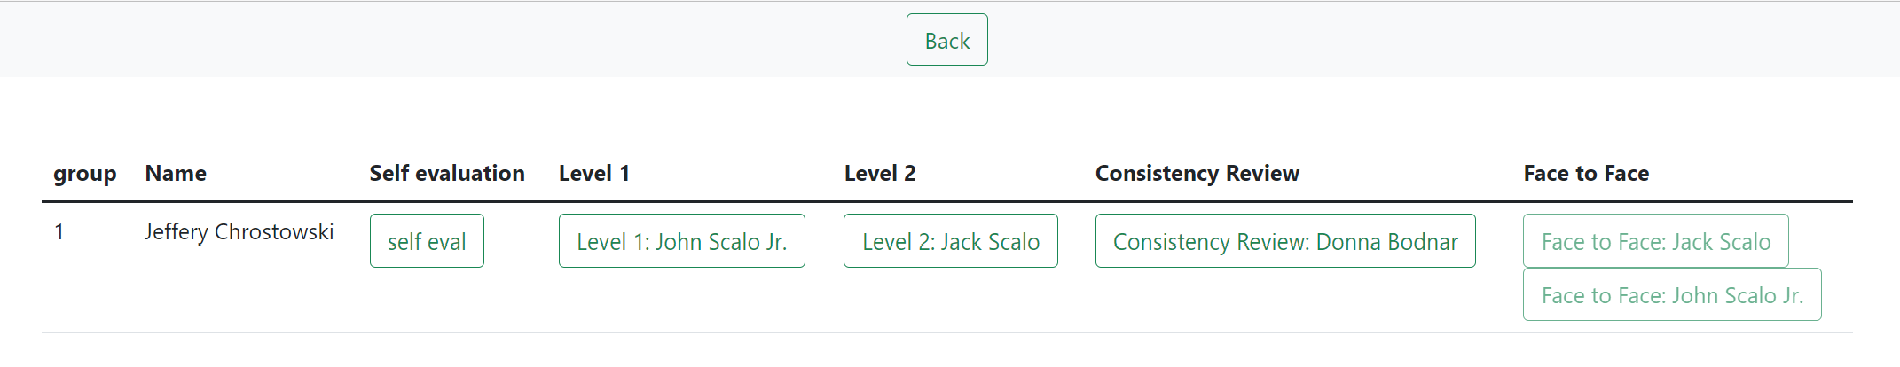

**View upon clicking on a user**

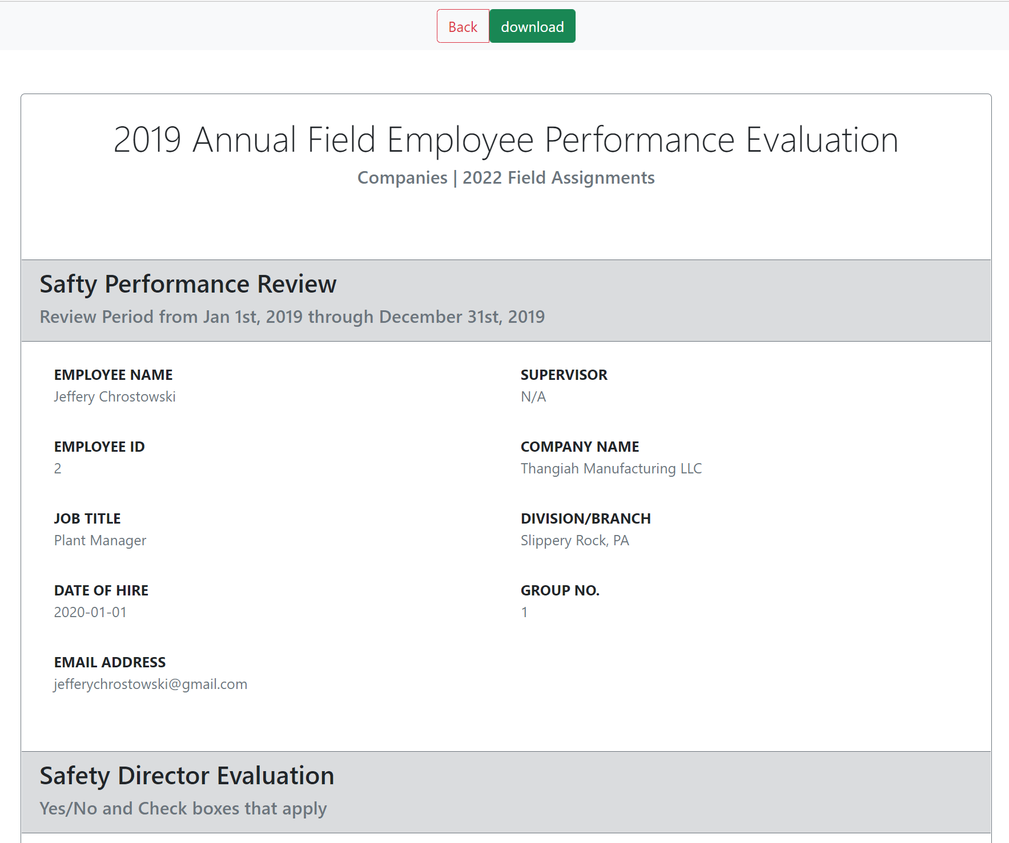

**View upon selecting an evaluation to view, where the option to download an attached file is possible**

## 3.2.3 Groups Button: Editing a Group

Pressing the “Edit group” that’s located next to each group will allow the user to makes changes to the reviewees and evaluators in the respective group.



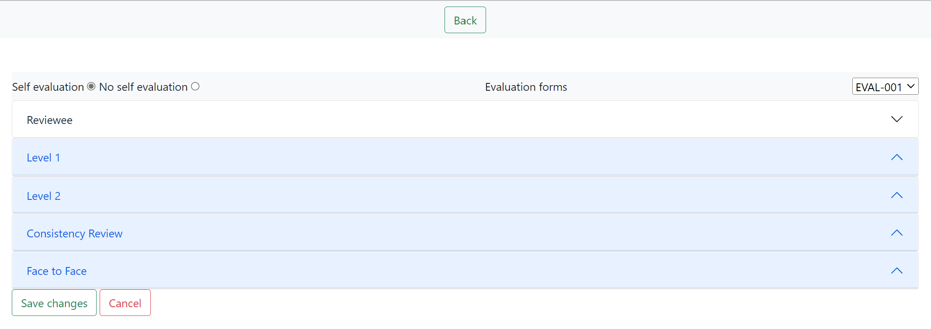

**Default View for “Edit Group” page**

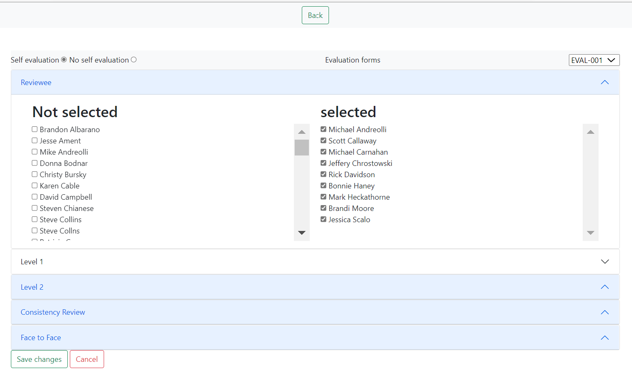

**View once the “Reviewee” drop-down is pressed. Similar views are present when pressing the other tabs such as “Level 1”**

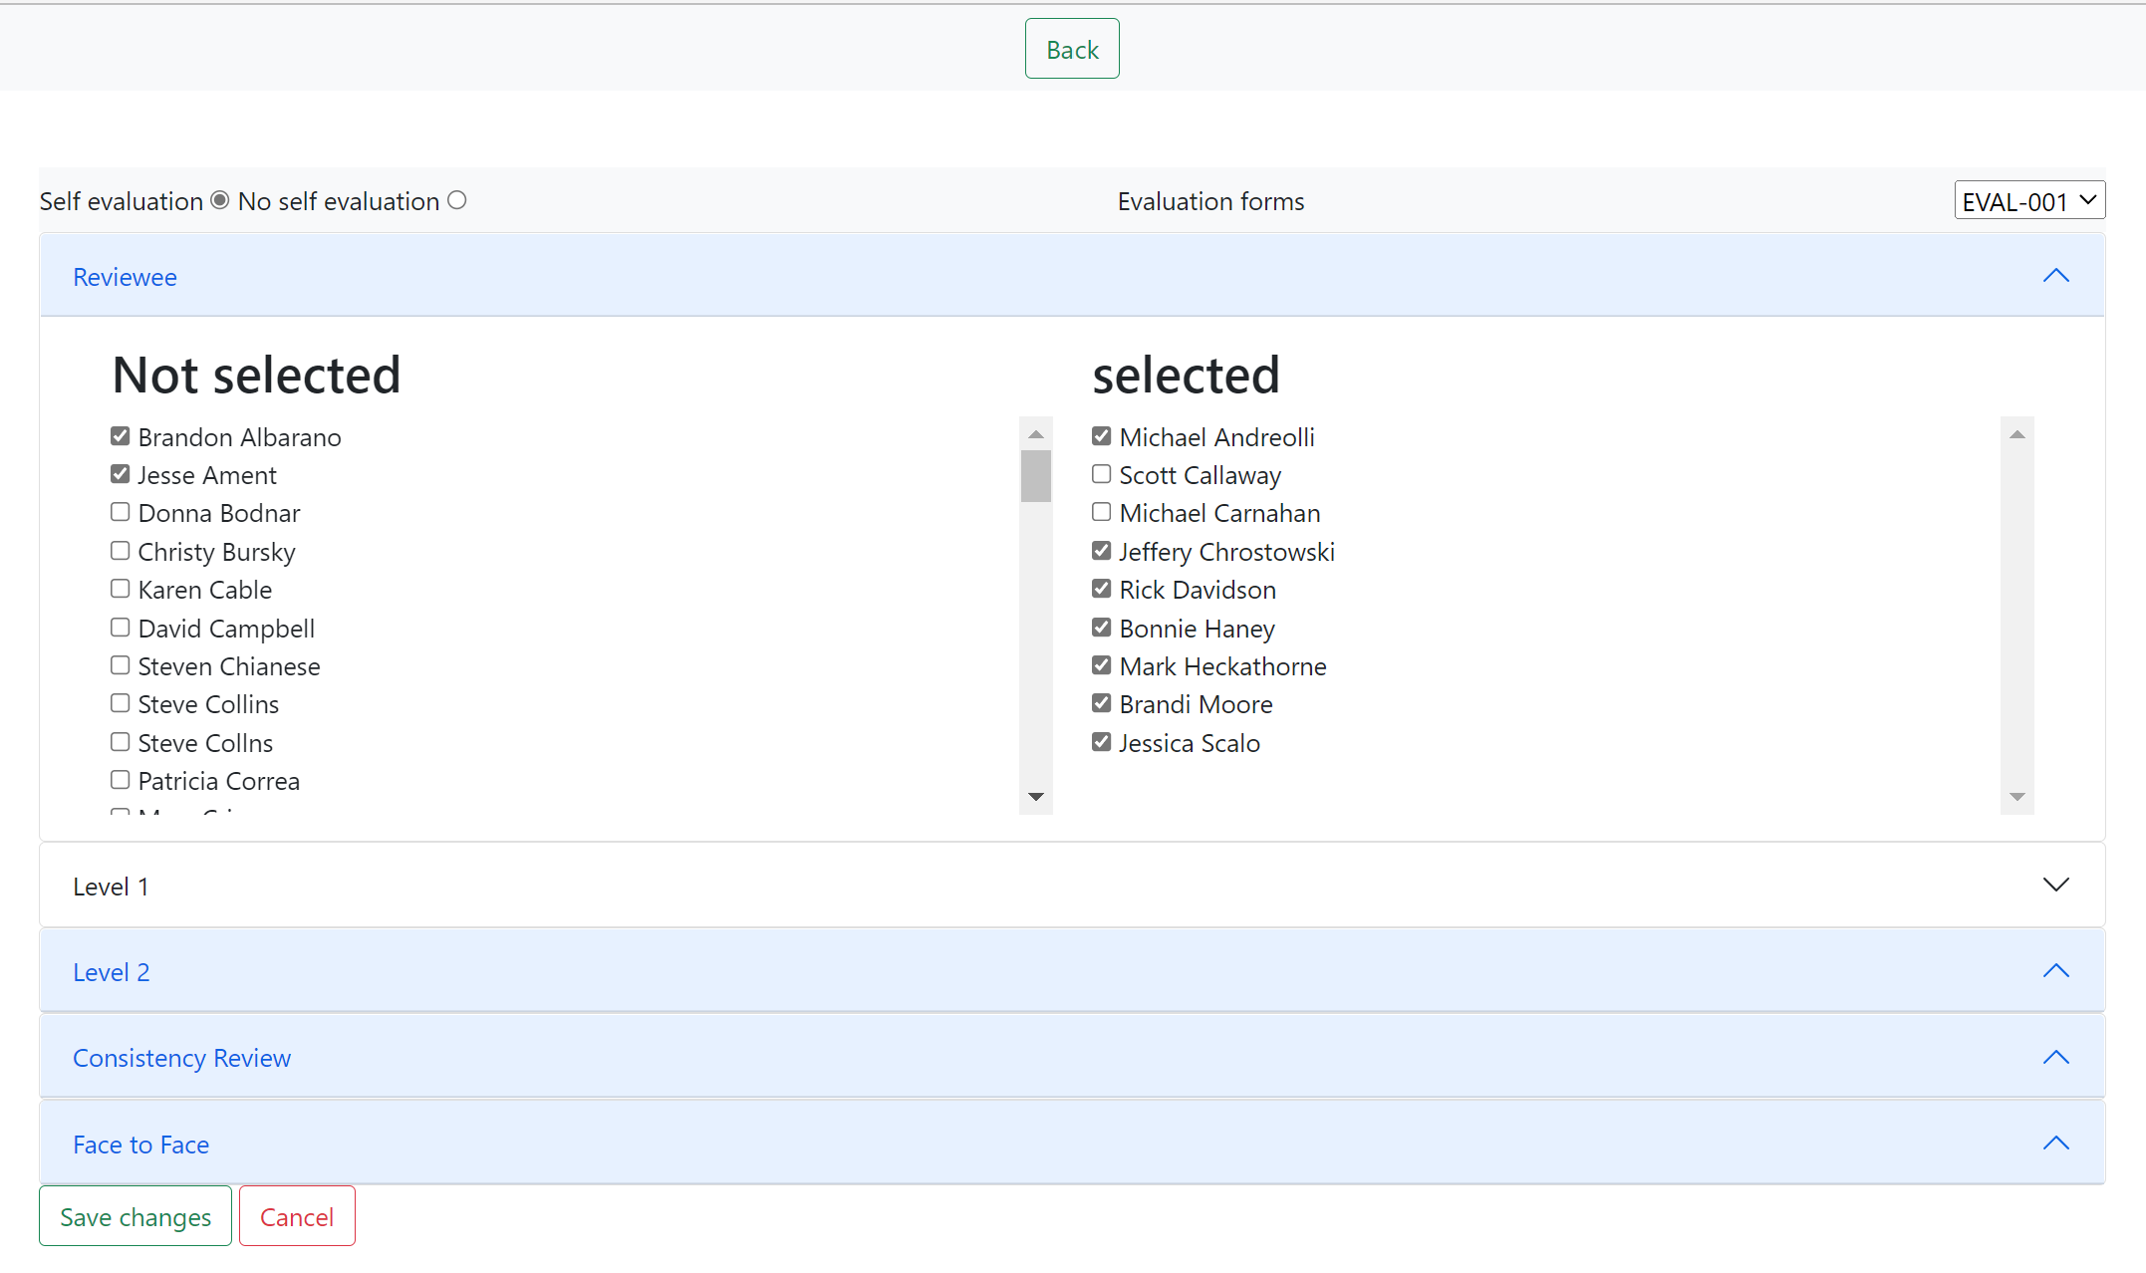

**View of changes being made (Adding Brandon Albarano and Jesse Ament and removing Scott Callaway and Michael Carnahan to and from the “Reviewee” section)**

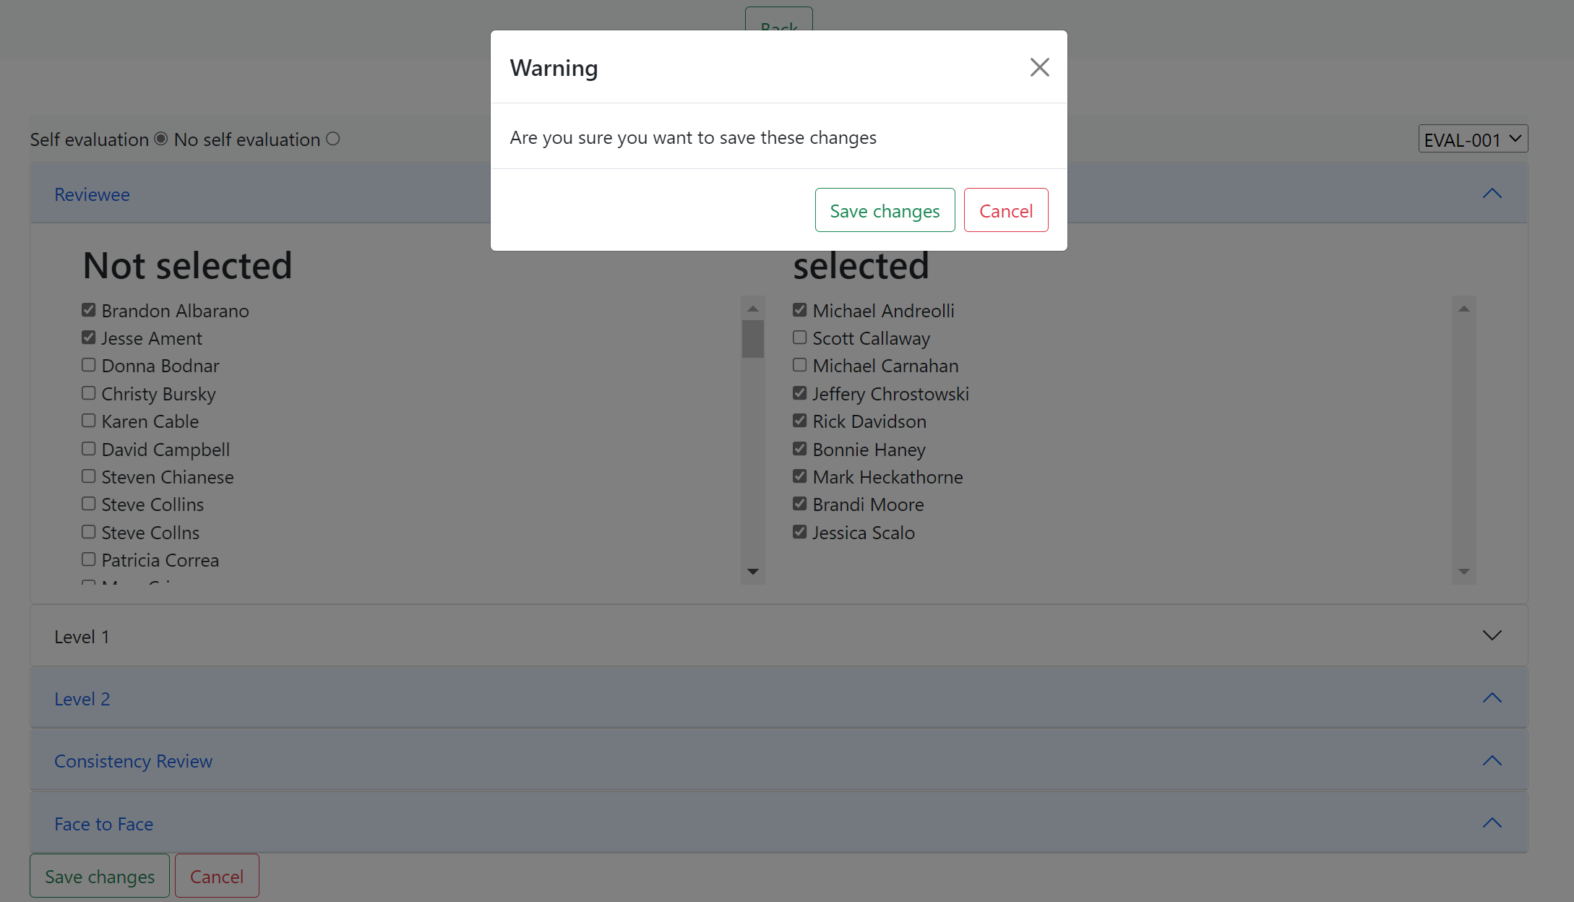

**View upon pressing the “Save changes” button at the bottom of the screen**

Pressing the “back” button will take the user to the previous screen, the eval_admin-group page, while the “save changes” button at the bottom of the screen will save any changes made to the group but remain on the group editing page.

## 3.2.4 Groups Button: Deleting/Archiving a Group

The option to delete a group comes with the button labeled “Delete Group” which is located beside each group listed. A delete button will only attempt to delete the group it sits beside. A group can only be deleted if there are no completed evaluations done for the group. If there is at least one completed evaluation, then the delete button will only serve to archive the group and its evaluations.



**View of groups pre deletion**

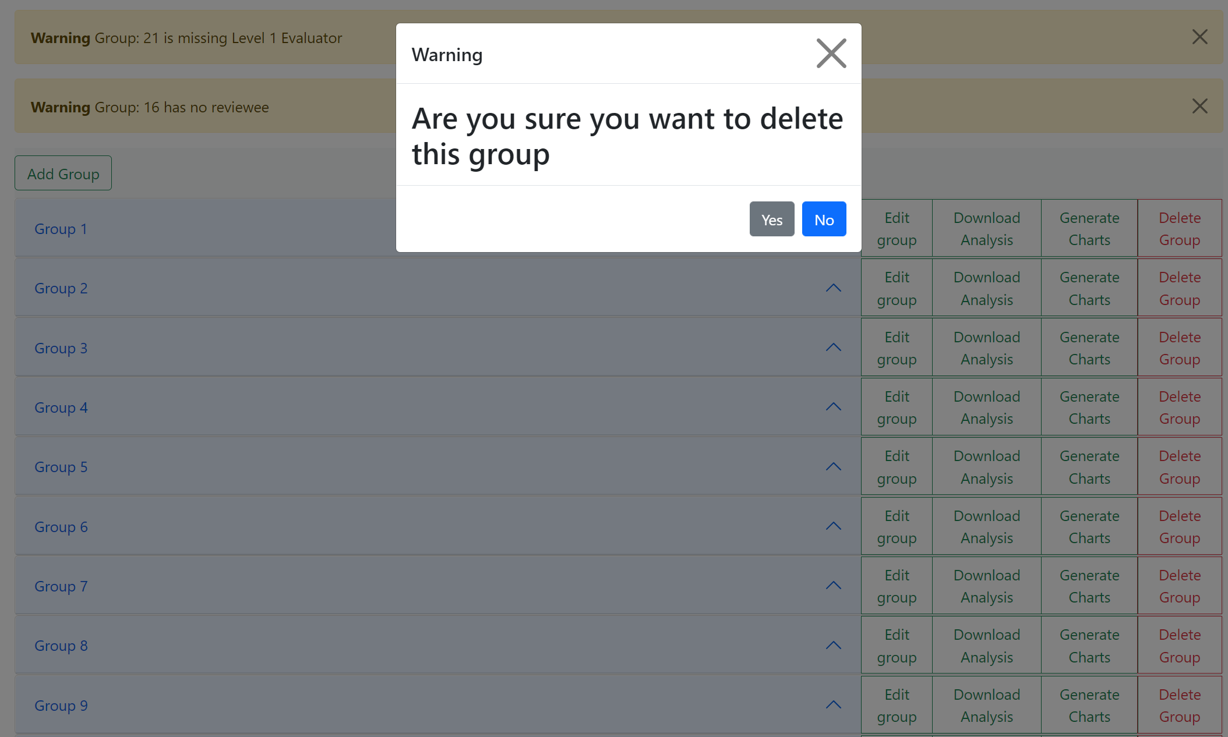

**View upon pressing a “Delete Group” button (the group in this example being Group 6)**

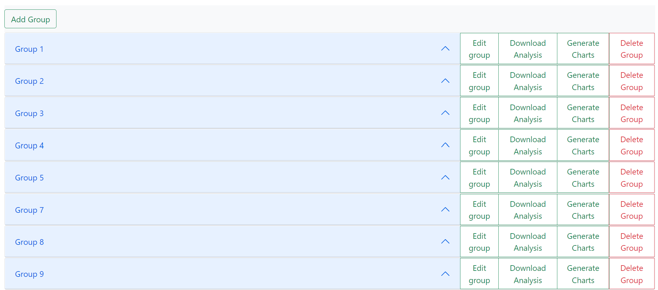

**View post deleting a group by pressing the “yes” button upon receiving the deletion prompt (Group 6 deleted)**

## 3.2.5 Groups Button: Chart Generation/Download Analysis for a Group



The “Download Analysis” button serves a similar purpose to the one located on each evaluation form on the Evaluation Forms page for the “EVAL_ADMIN” role, but instead of the analysis results on every person evaluated on the respective form, it is the results exclusive the particular group selected

An “EVAL_ADMIN” also has the option to view data visualizations of the evaluations for users in a group upon pressing the “Generate Charts” button which is also located beside each group listed. The button will take the user to a page where several types of charts can be selected from for each individual user for each evaluation done on them as well as an average all the evaluations for a user. Each user also has a button associated with them, once an evaluation has been performed on them, that is called “Pdf Generation” that when press, will download a pdf file with the four types of charts displayed on the file as well as information about the results.

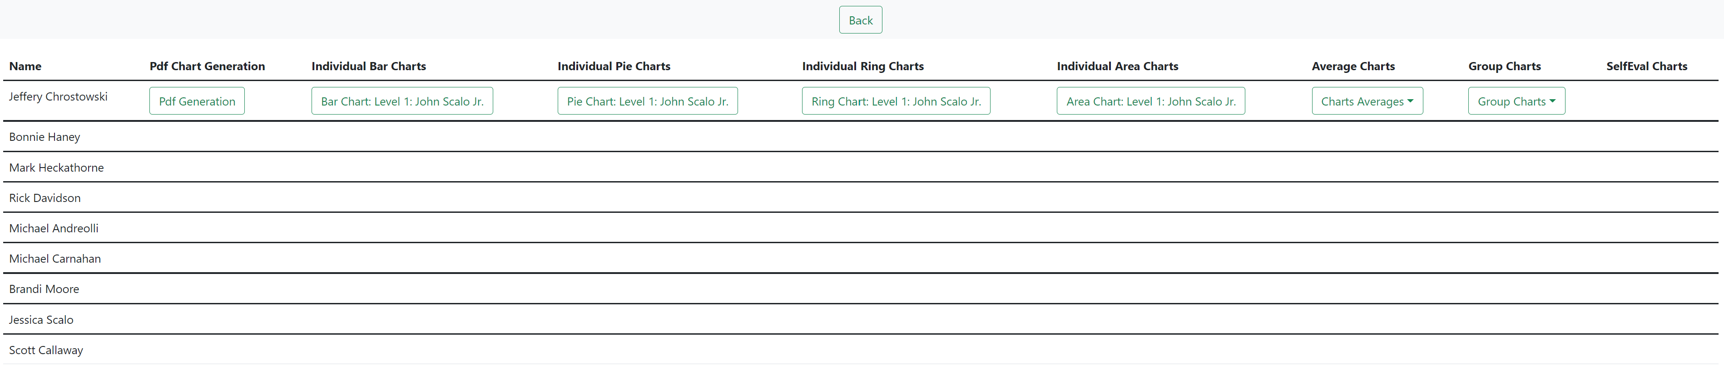

**View after pressing “Generate Charts” button on a group that has at least a single evaluation done**

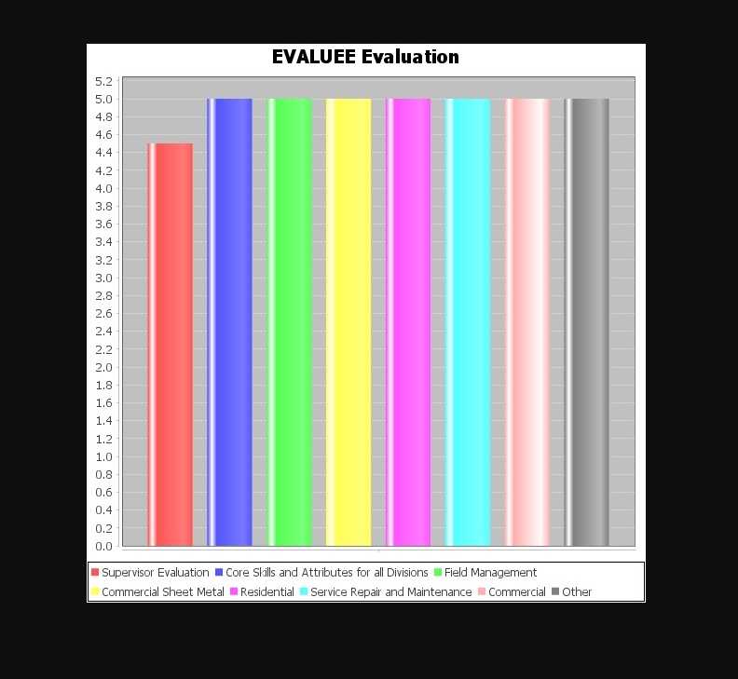

**View after pressing “Bar Chart Level 1: John Scalo Jr.” from the previous figure**

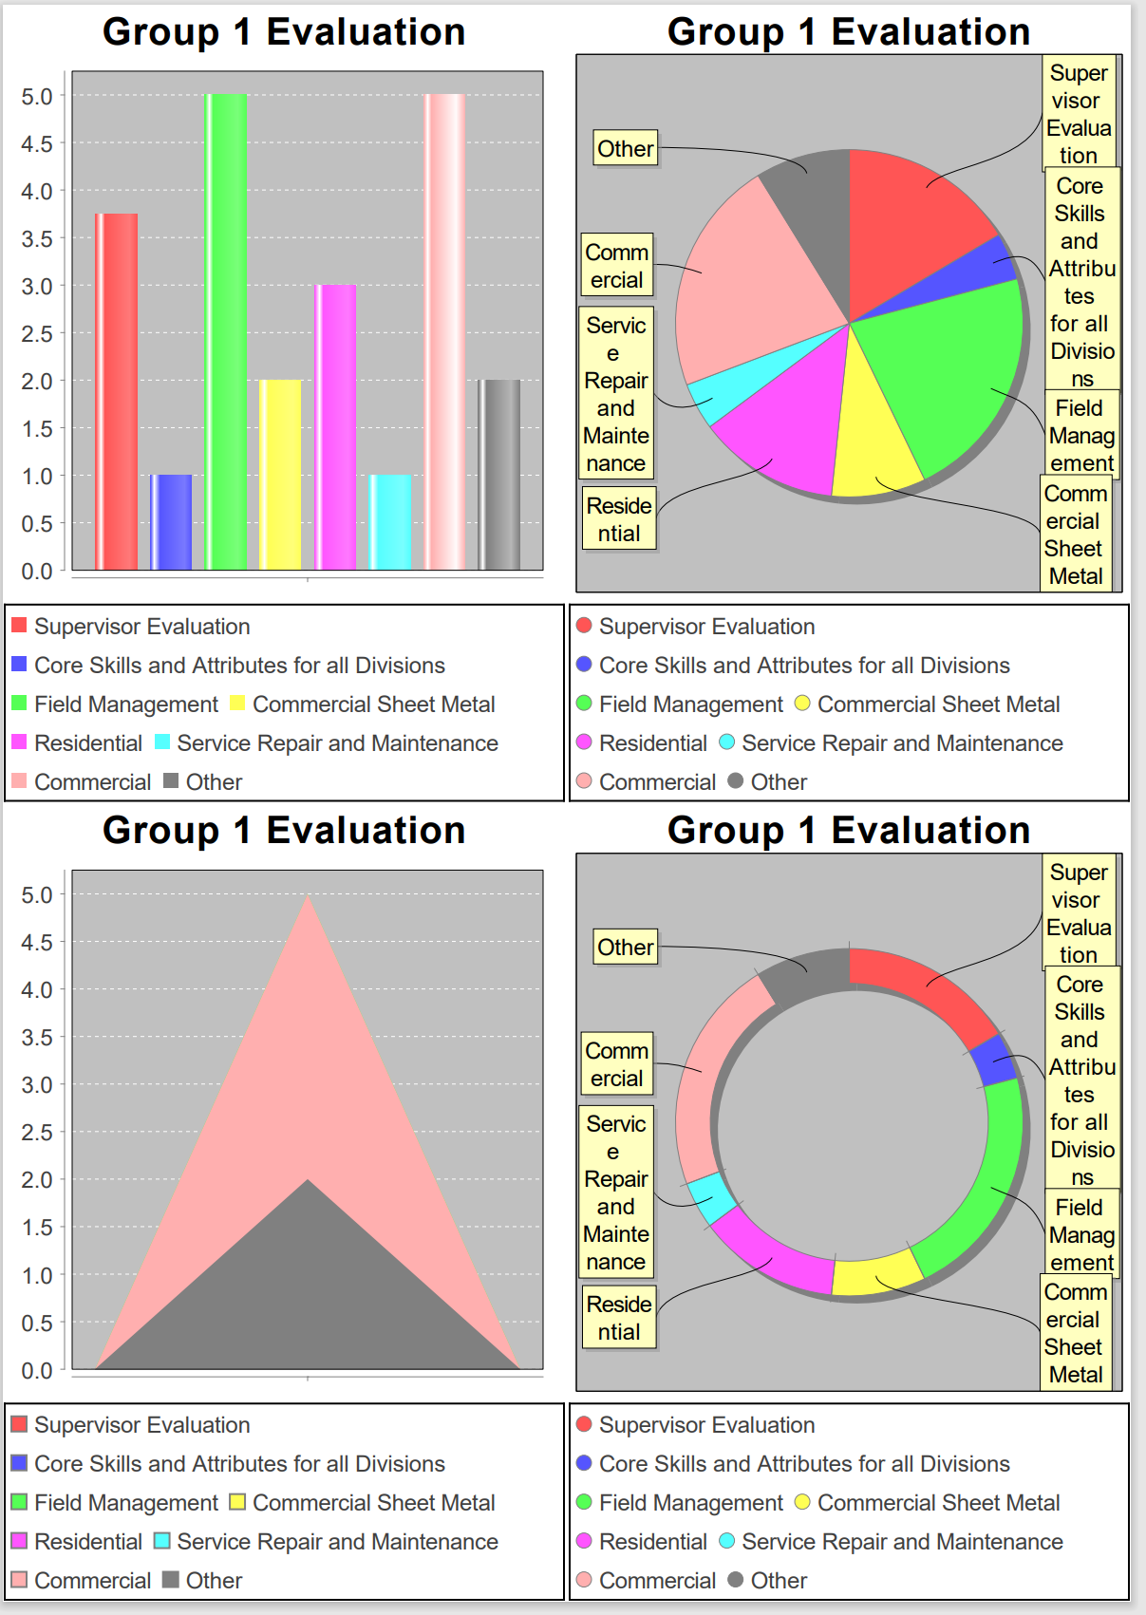

**Partial view of the pdf generation file that’s downloaded when the “Pdf Generation” button is pressed**

## 3.3 Archive Navigation Bar Options

Upon navigating to the Archive button, the user will be greeted with a page if a group with completed evaluations has been deleted. If there hasn’t been a group with completed evaluations deleted, then the page would be blank aside from the navigation bar. From this page, the user may view archived group evaluations done by clicking on the “View” button next to each evaluation.

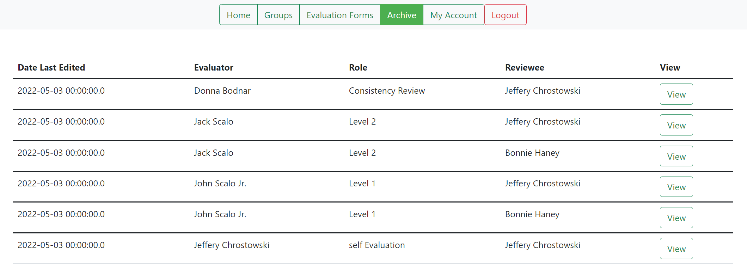

**View of the Archive page if groups with completed evaluations were attempted to be deleted**

The “View” button displays the evaluation in the same way as previously shown in section 3.2.2

# Section 4 Users Abilities

Now, onto users with the “USER” role and what they can do and see. An account with the role “USER” can be accessed after uploading the “Review_Data_Upload_Users.xlsx” file where the user [jessicascalo@gmail.com](mailto:jessicascalo@gmail.com), with the password “test”, can be used. This particular user will need to have their password reset since it’ll be their first log in, see section 1.2 on what that is like. Upon doing their first password reset, that will no longer pop up on logging in and they will be able to proceed with this process once they attempt to log in once more with the new credentials. After that event, the user will be able to see a Home, My Evaluations, My Account, and Logout on the navigation bar. All buttons on the navigation bar serve the same purpose as the ones that users with the “ADMIN” role do other than the My Evaluations button.

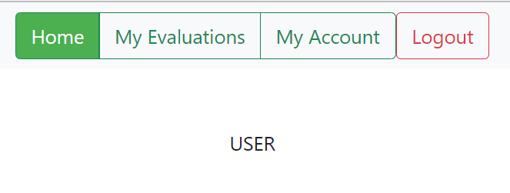

**Default view**

## 4.1 Evaluation

The My Evaluation button provides the user to write their own self-evaluation. Upon clicking the My Evaluation button, the user will be taken to a webpage where any evaluations that either have or need to be done. The user may select evaluations done on them, or perform a self-evaluation with the “Complete Self Evaluation” button if any are available/allowed to be done.

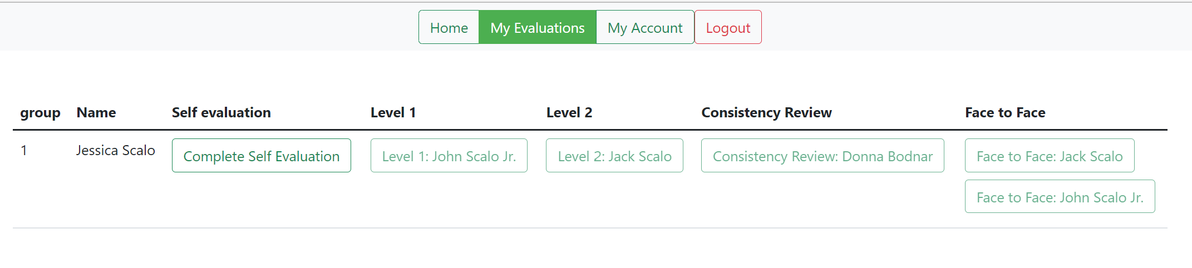

**Default view**

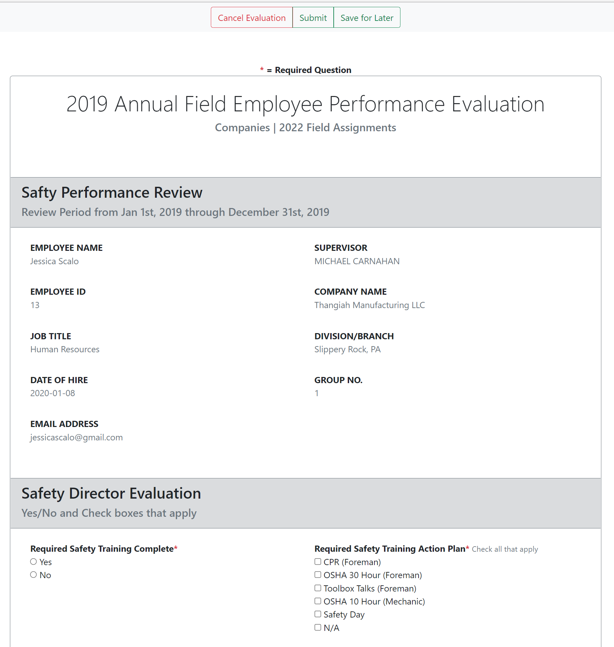

**Default view of the self-evaluation page after pressing the “Complete Self Evaluation” button**

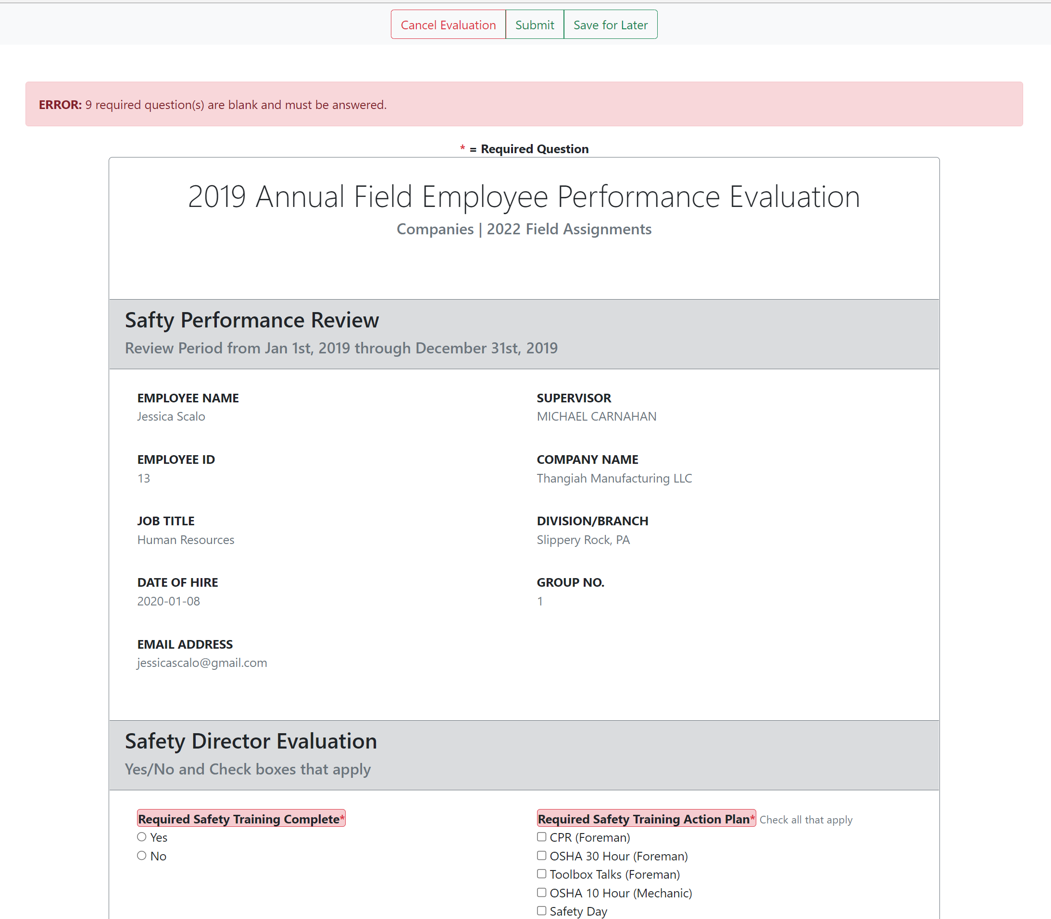

**View upon trying to submit any type of evaluation without completing the required questions**

The “Cancel Evaluation” button at the top will bring the user back to the home page. The “Submit” button must be pressed in order to save the changes made to the evaluation form. Once submitted, the user will automatically be taken back to the home page.



**View after pressing the “Save for Later” button during the self-evaluation**

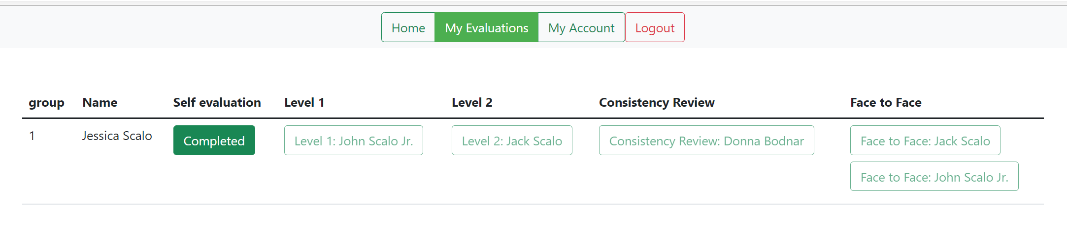

**View upon filling out the required questions and clicking “Submit” during the self-evaluation**

# Section 5 Evaluator Abilities

The last roles to talk about are the “EVALUATOR” and “EVALUATOR_EVAL” roles which only login and view a basic evaluator page where four options lie: Home, Evaluate/Evaluation Groups, Account, and Logout. Users with the “EVALUATOR” role only serve to perform evaluations, while those with the “EVALUATOR_EVAL” role can perform evaluations as well as have evaluations done on them.

The “EVALUATOR_EVAL” role has the “Evaluate” drop-down which has the “View Groups” button to view groups to perform evaluations and the “My Evaluations” button to see evaluations to be performed on them as well the ability to perform a self-evaluation. Normal evaluators only have an “Evaluation Groups” button which serves the same purpose of the “View Groups” button the other role possesses. The following demo will use the user [johnscalo@gmail.com](mailto:johnscalo@gmail.com) with the password “test”. Using John Scalo will also result in a reset password prompt just like what was done with Jessica Scalo. An example of what that looks like can be seen in Section 1.2.

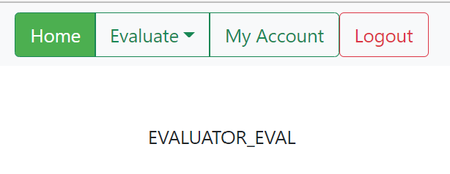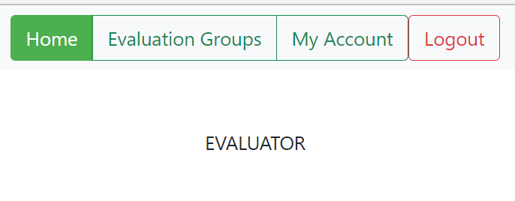

**Default views depending on “EVALUATOR_EVAL” and “EVALUATOR” respectively**

## 5.1 Evaluate

Clicking on “Evaluate” will provide a drop-down menu where the following selections are available: “View Groups” and “My Evaluations”. The “My Evaluations” button will bring forth a page where the user may see evaluations being done on them, this feature must be moved to the “EVALUATOR_EVAL” role. The “My Groups” button on the other hand functions as intended and will relocate the evaluator to the evaluator home.

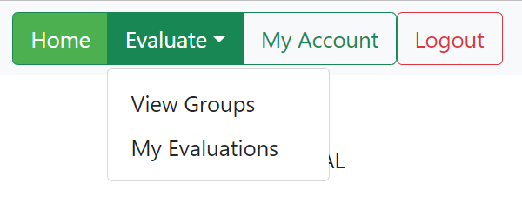

**Default view of the “EVALUATOR_EVAL” on the home page upon clicking the “Evaluate” drop-down button**

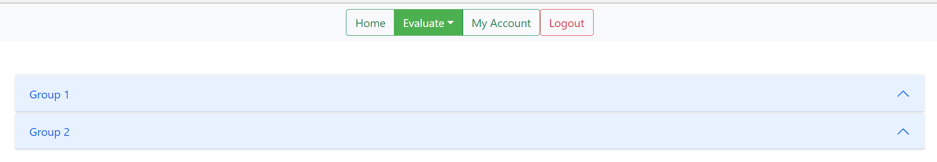

**View upon clicking on “View Groups”**

From here, the webpage will display all the groups that the current evaluator must take part in evaluating. Clicking on a group will expand a section that’ll tell of the users being evaluated, as well as their evaluators and levels. The levels are clickable only if the user has access to start evaluating. Access for evaluating is based on rank where lower levels must be completed first.

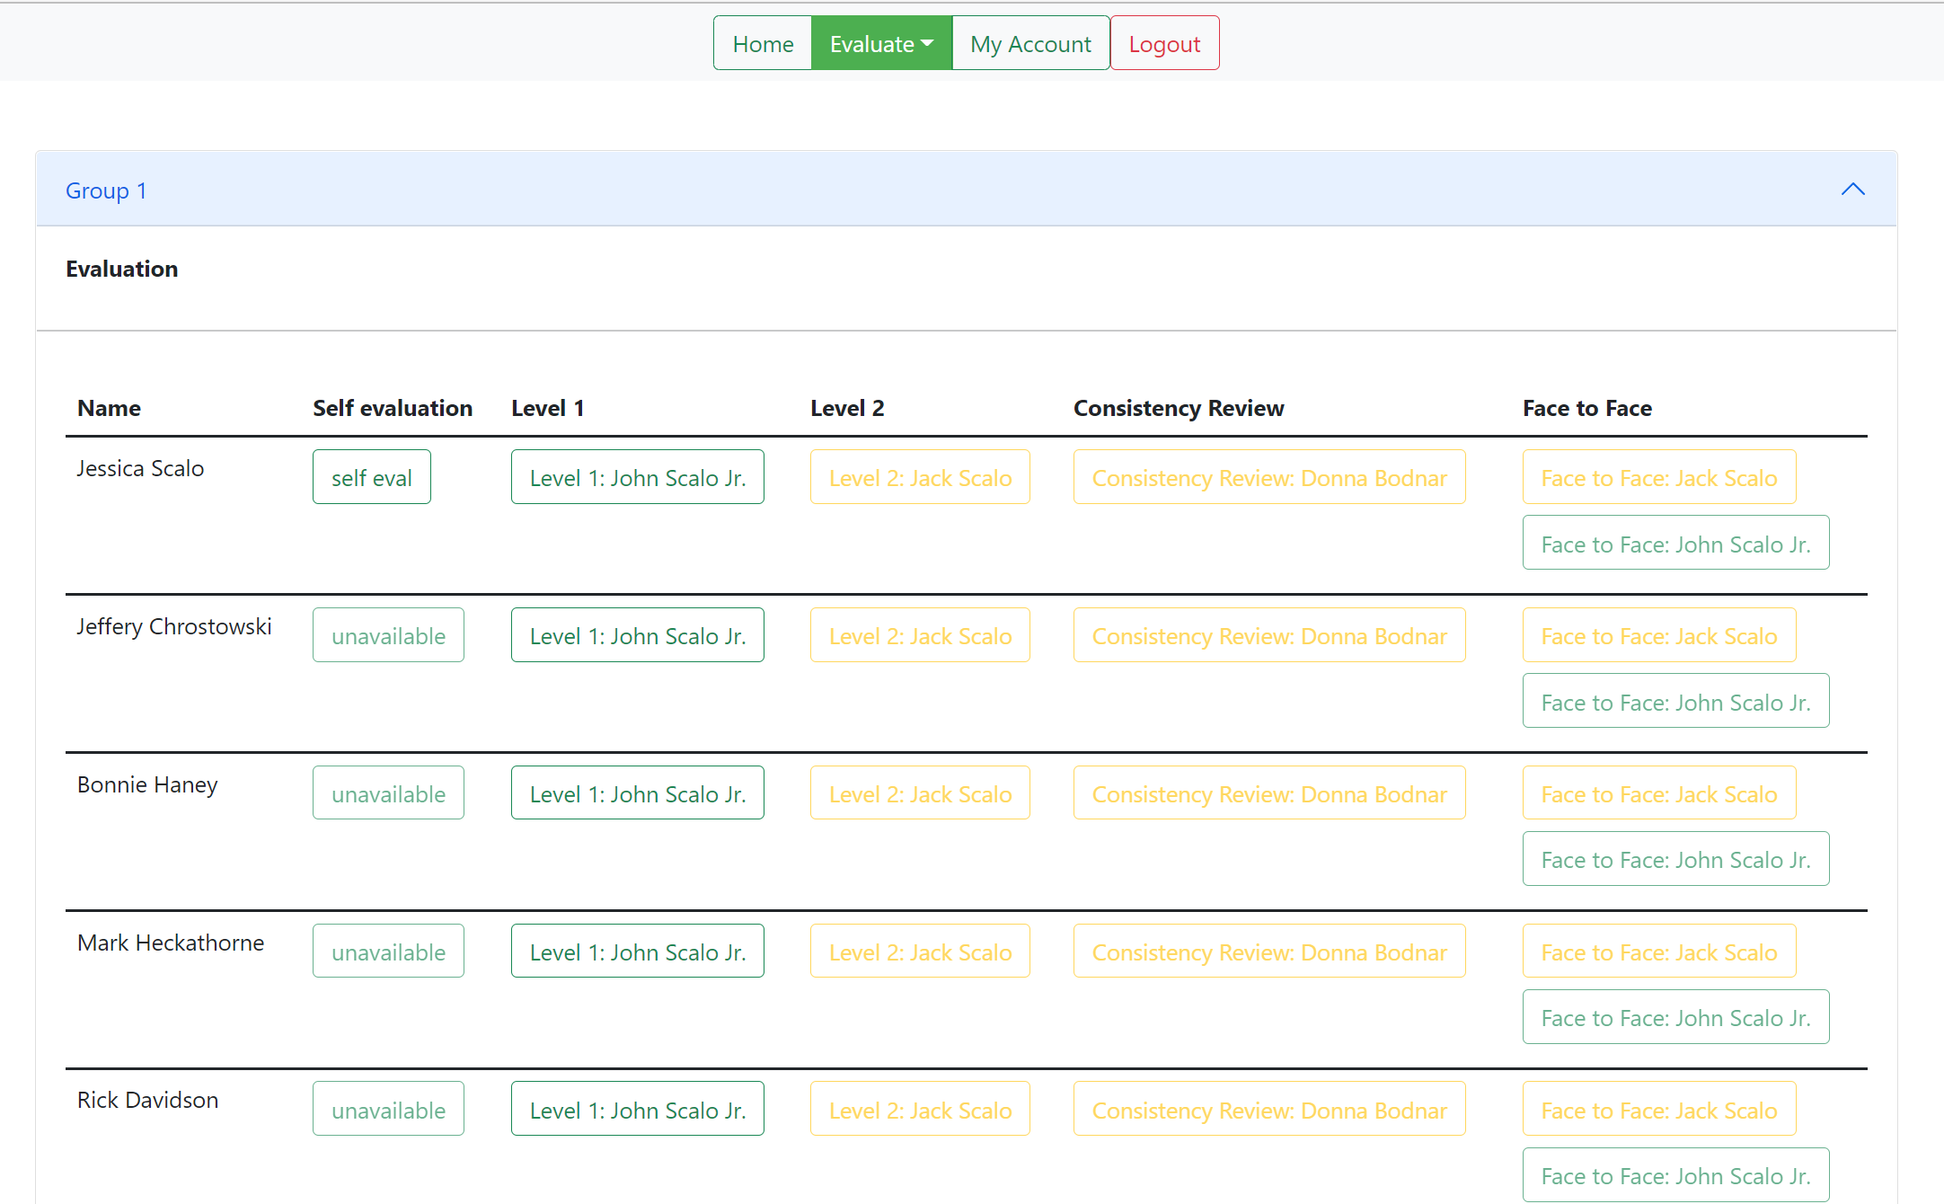

**View after pressing one of the groups’ drop-down buttons**

Upon clicking a level to review, such as “Level 1: John Scalo Jr.” for the user “Jessica Scalo”, the evaluator will be taken to a webpage to begin an evaluation. Any edits down to the page can be saved and a score is given for drop-down related answers. Files with a size of 8 megabytes or lower may be uploaded along with the submission of the file by clicking the “Choose File” at the top of the form. The form can be saved by scrolling to the top or bottom of the page and clicking “Submit”, after filling out the necessary questions, “Save for Later” in order to be able to revise and finish the evaluation, or cancel and go back by clicking the “Cancel Evaluation” button.

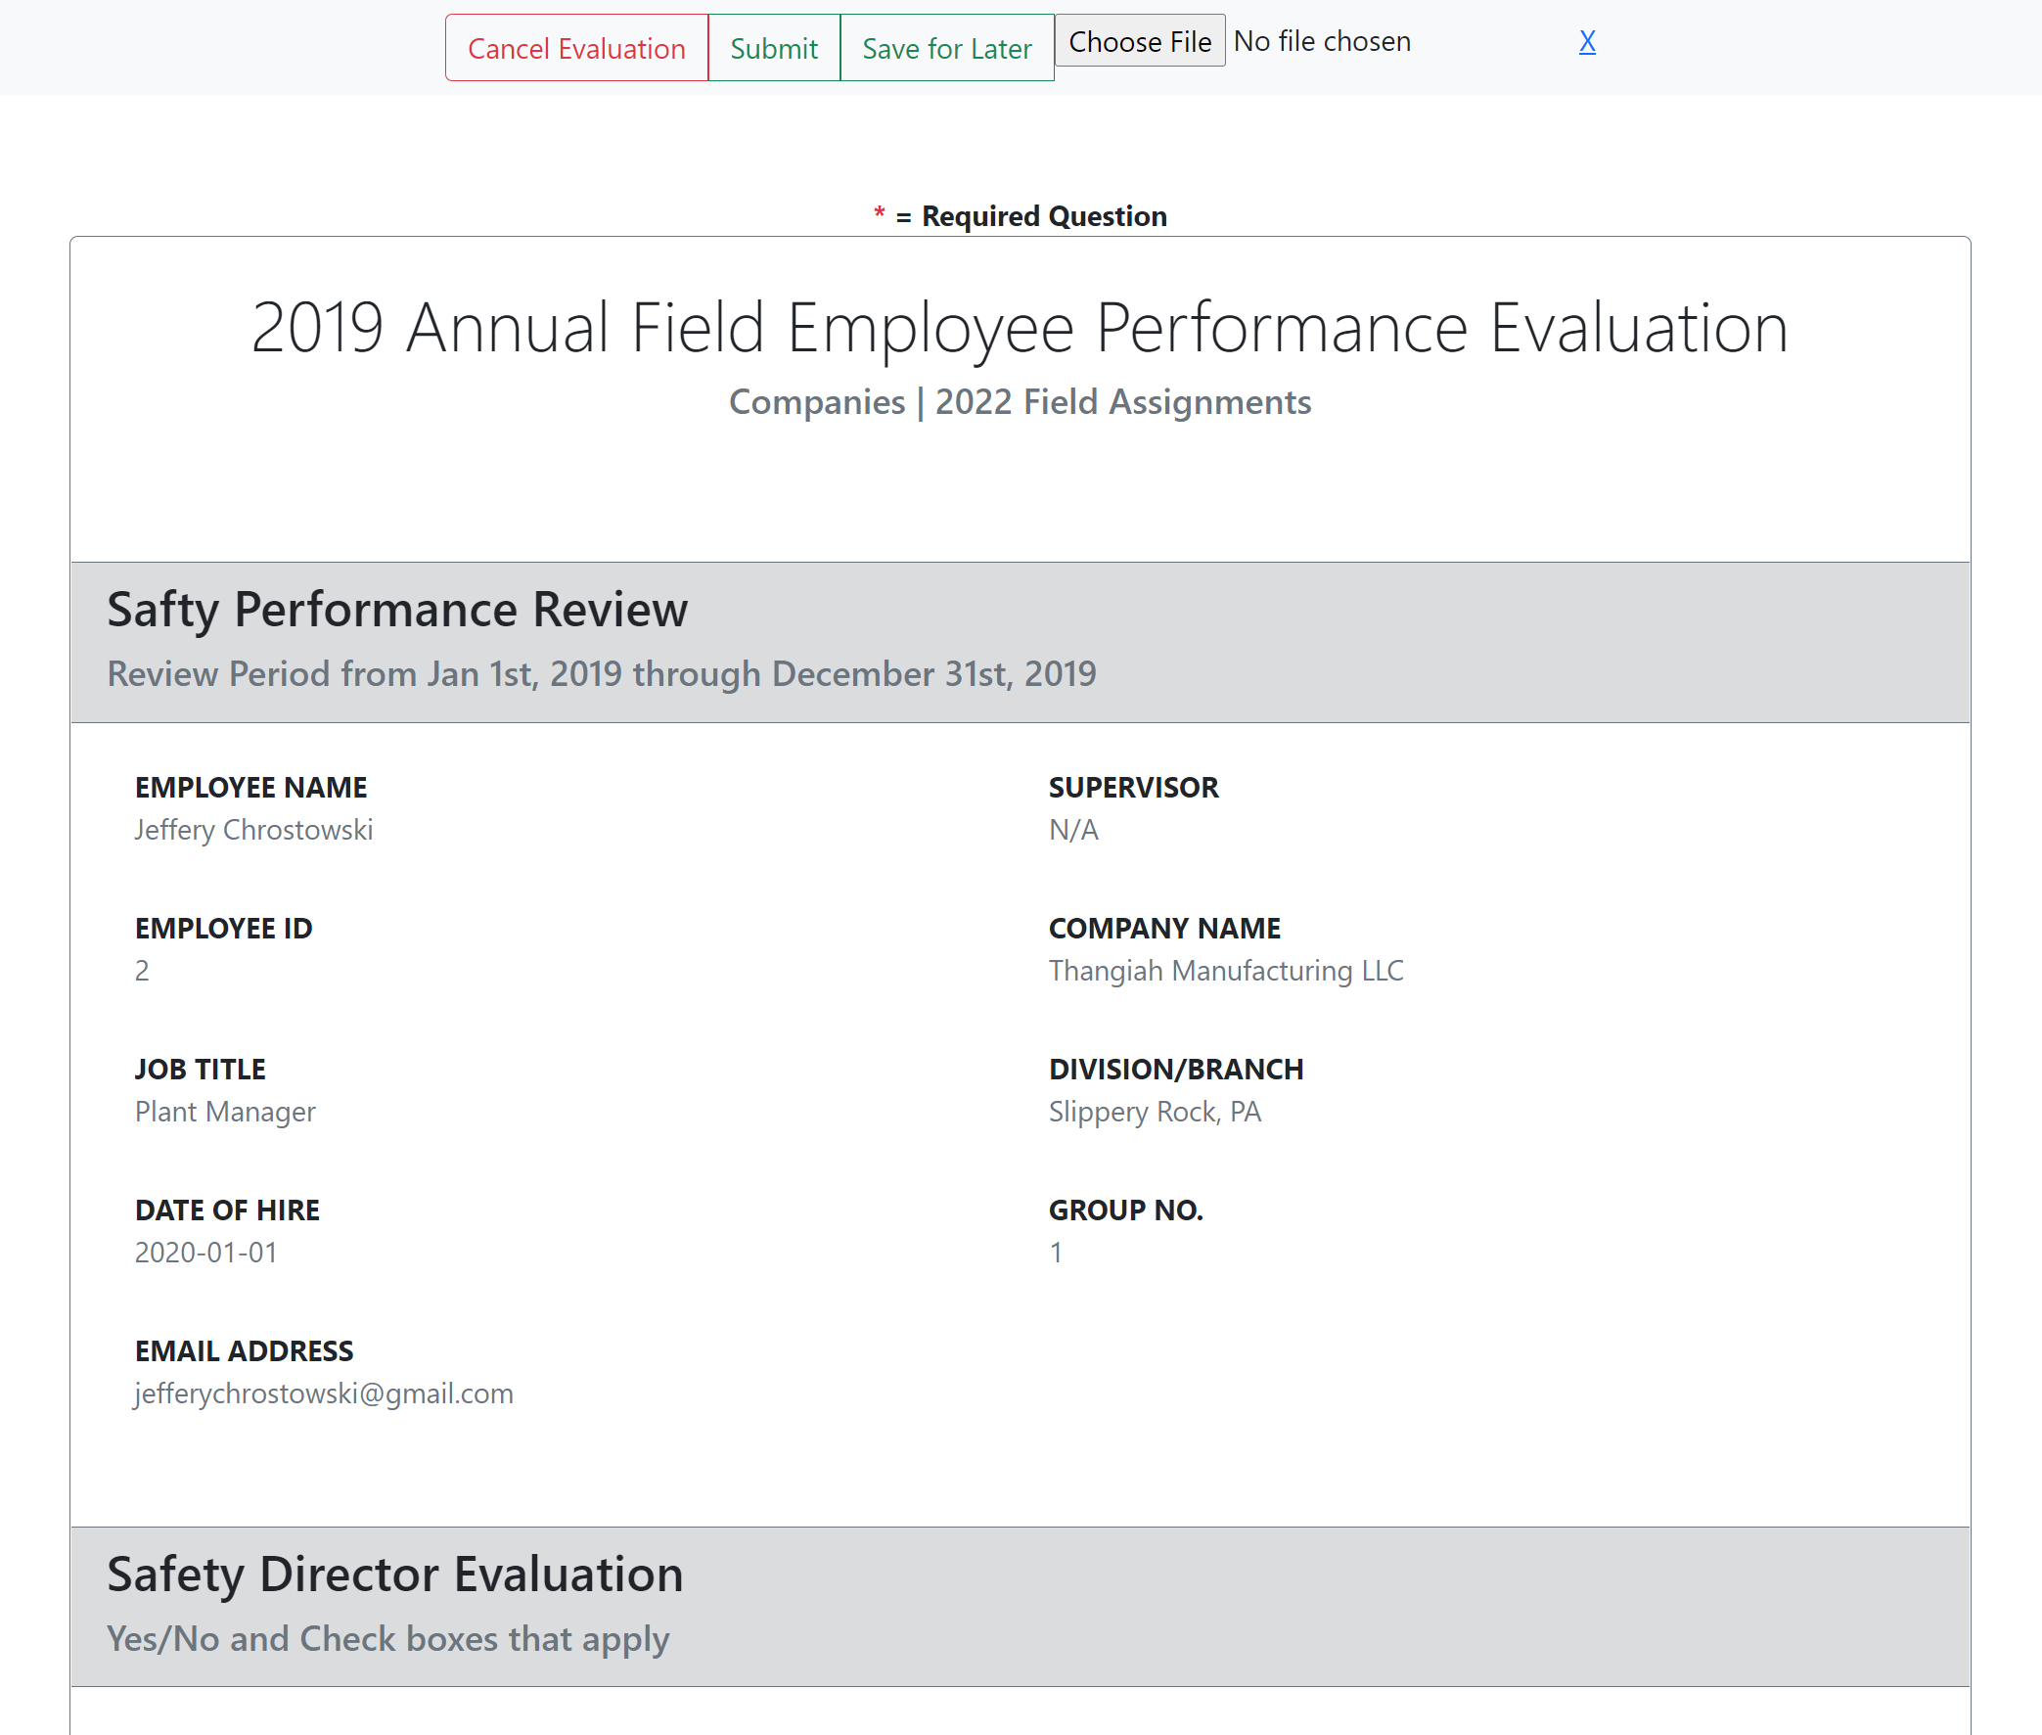

**View after selecting an available evaluation to be completed**

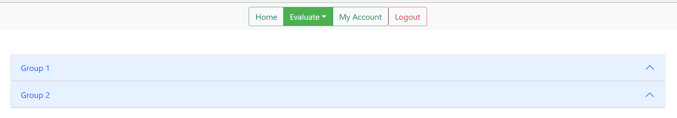

**View upon completing an evaluation (similar popups and mechanics from the self-evaluation section apply to normal evaluations as well)**

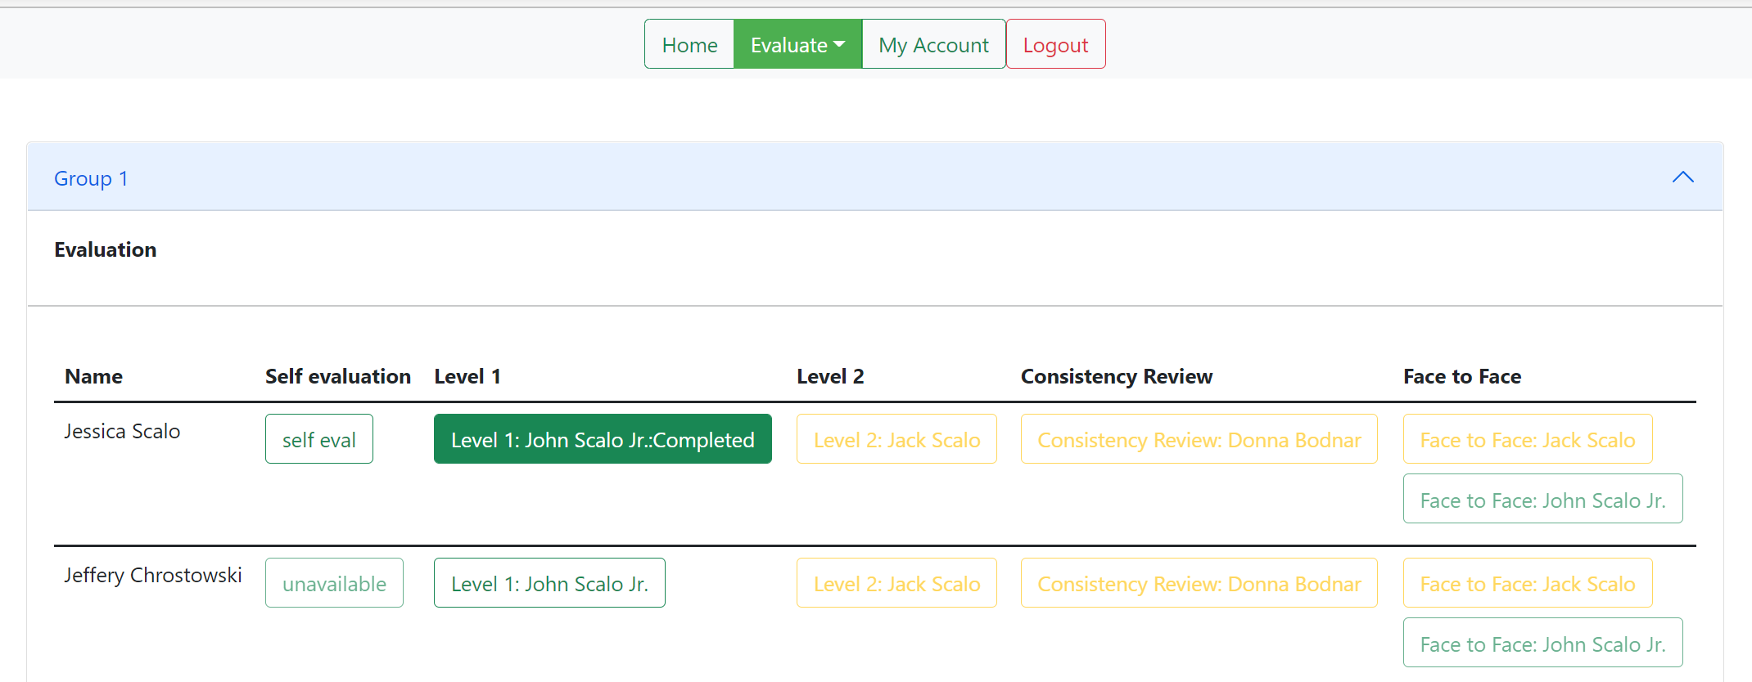

**View upon displaying the contents of a group that the user completed an evaluation on**

After submitting the evaluation, it’s possible to view what was submitted by following the previous steps for performing an evaluation. From the preview screen of an evaluation, you may download the attached file with the “download” button. Other evaluators that are of a higher level can then complete their evaluations as each lower-level evaluator completes their evaluations. The next-up evaluator after “John Scalo Jr.” for the user “Jessica Scalo” would be “Jack Scalo”, which the user information for them upon logging out of “John Scalo Jr.” is: [jackscalo@gmail.com](mailto:jackscalo@gmail.com) and “test”. After resetting “Jack”’s password (Refer to section 1.2) The user “Jack Scalo” can access the “Level 2: Jack Scalo” evaluation for Group 1’s “Jessica Scalo”.

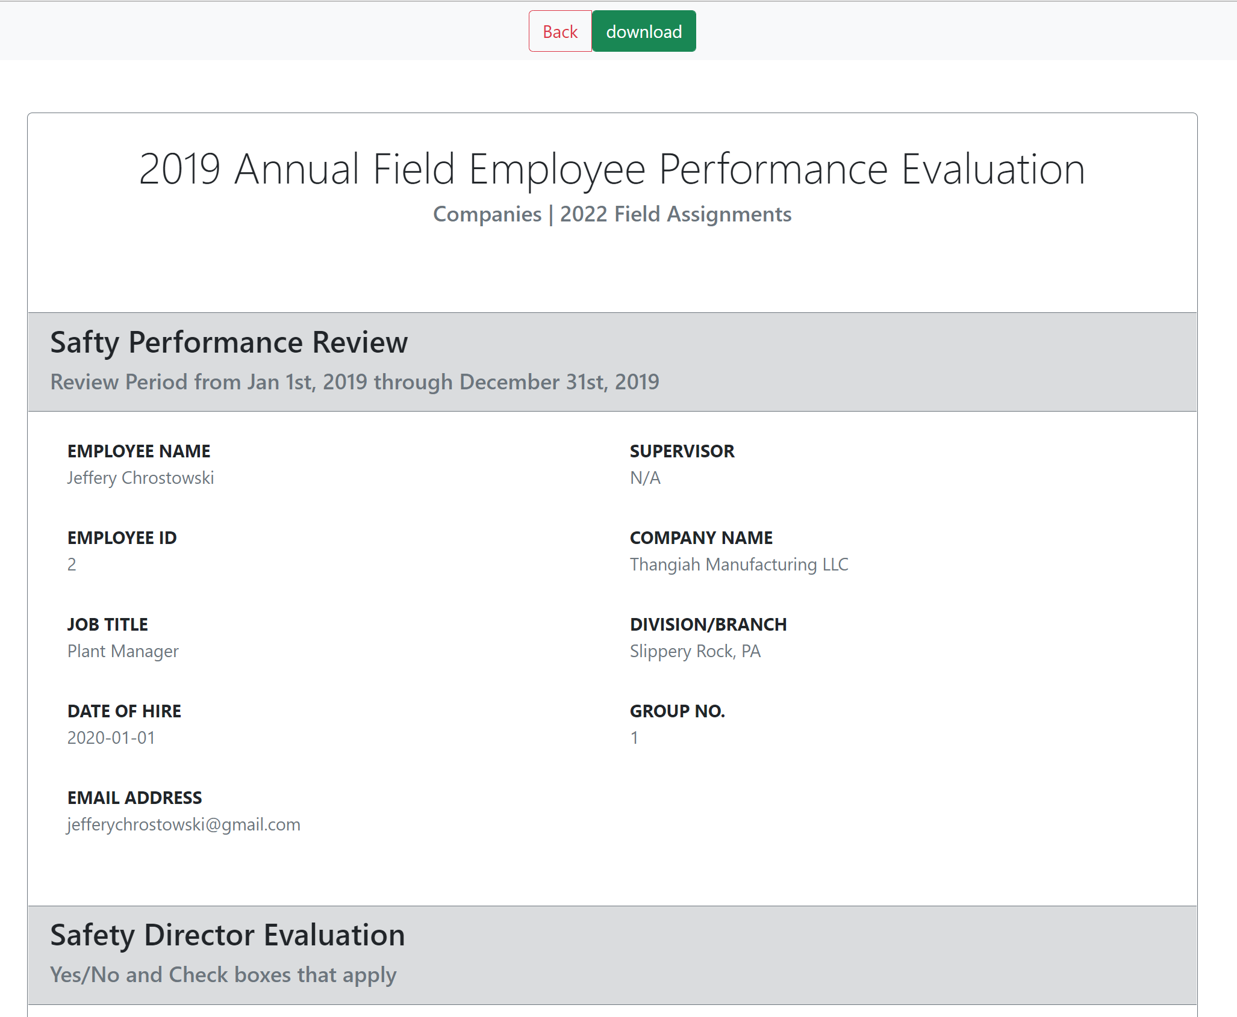

**View upon clicking the previously completed evaluation to preview the evaluation. The “download” button is present to download the attached file**

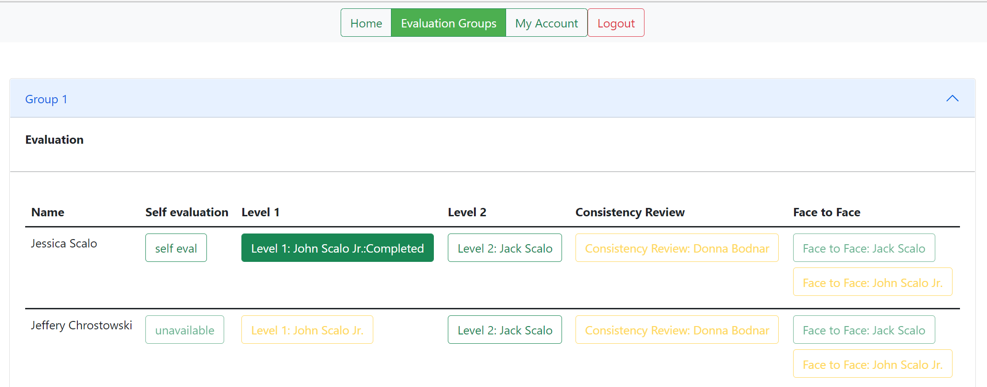

**View upon logging in to** [**jackscalo@gmail.com**](mailto:jackscalo@gmail.com) **to complete the next level evaluation**